Database Assignment 1

1. To list all records with sal > 2000 and comm>200



1. To list all record with job=’Clerk’ or sal>2000

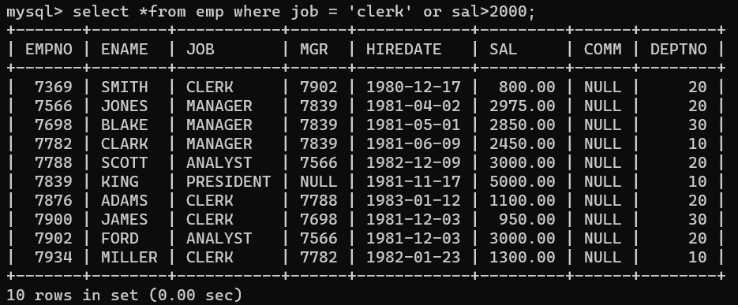

1. To list all the record with sal=1250 or 1100 or 2850

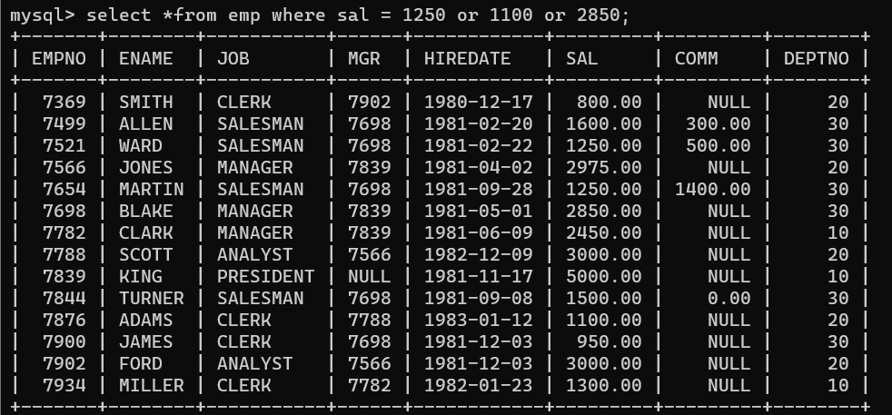

1. To list all employees with sal>1250 and <2850

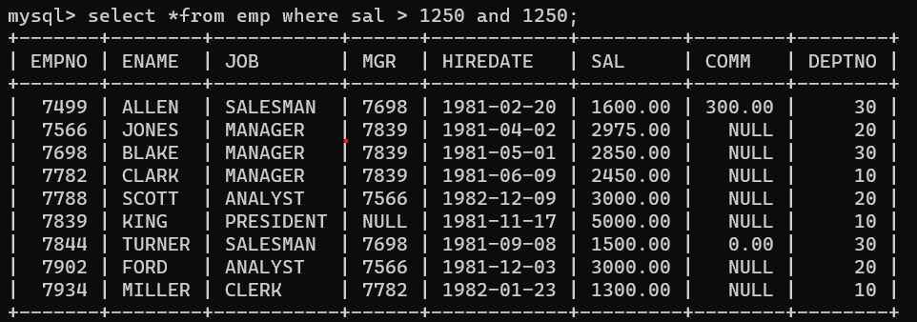

1. To list all employees with name ends with AS



6. To list all employees with job starts with C and ends with K

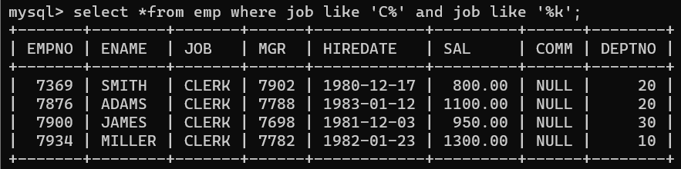

7. To list all employees with job contains L at third position and M at third last position

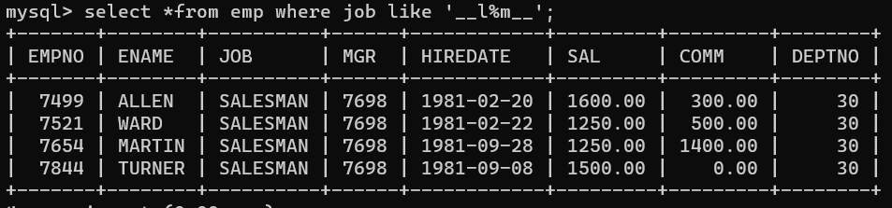

1. To list all the record with sal not equal to 1250 or 1100 or 2850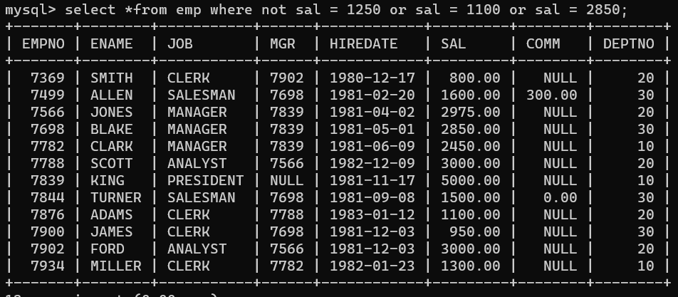
2. To list all employees with salnot >1250 and <2850

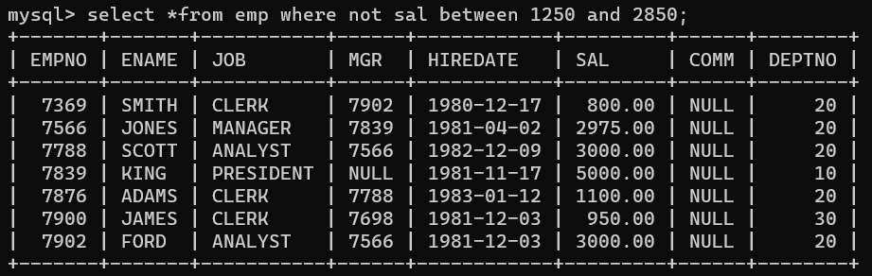

1. To list all employees with job starts with C , E at 3rd position and ends with K

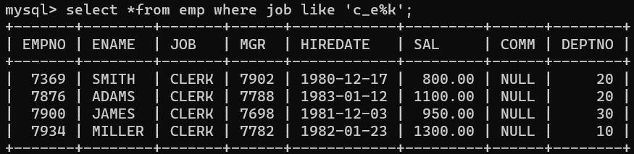

11. To list all rows with comm is null

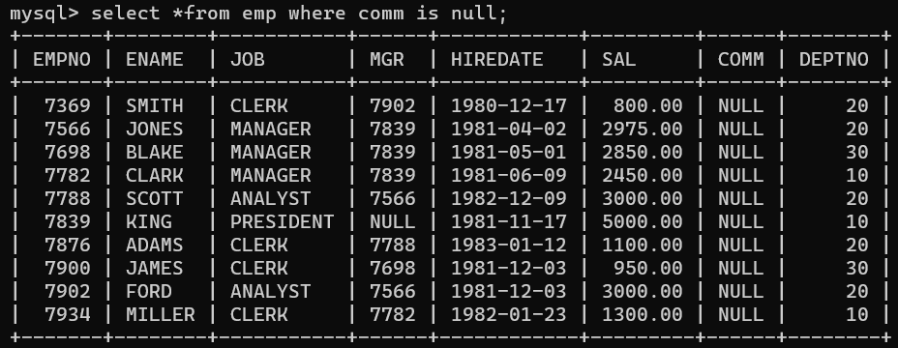

12. To list all employees with sal is null and name starts with ‘S’



13. To list all employees with job contains 5 characters

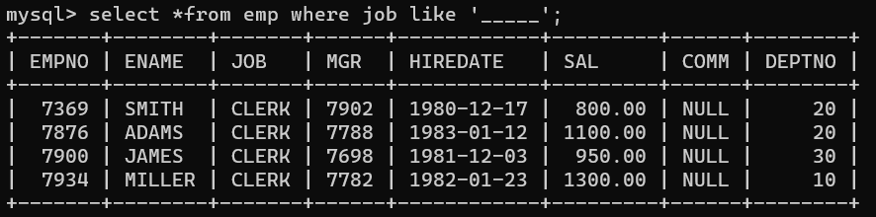

14. To list all employees with name contain ‘A’ at 1 position and job Contains 5 character

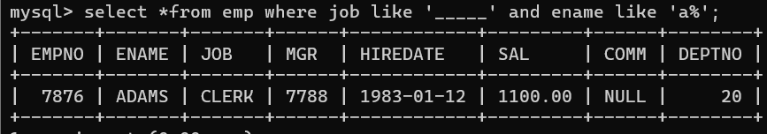

Q2

1. Retrieve the details (Name, Salary and dept no) of the emp who are working in department code 20, 30 and 40

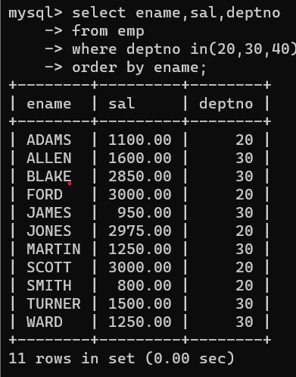

2. Display the total salary of all employees . Total salary will be calculated as sal+comm+sal*0.10

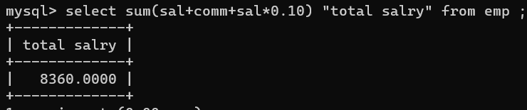

3. List the Name and job of the emp who have joined before 1 jan 1986 and whose salary range is

between 1200and 2500. Display the columns with user defined Column headers.

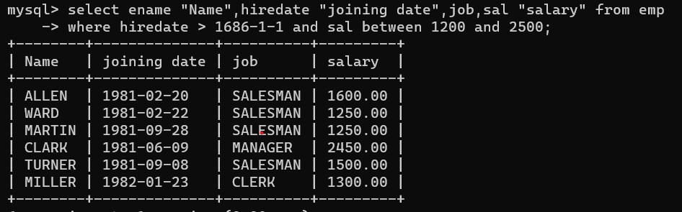

4. List the empno, name, and department number of the emp works under manager with id 7698

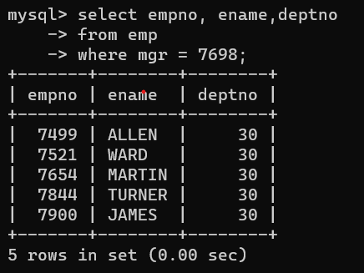

5. List the name, job, and salary of the emp who are working in departments 10 and 30.

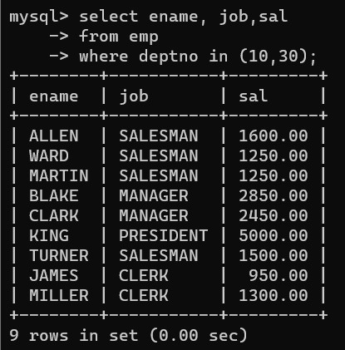

6. Display name concatenated with dept code separated by comma and space. Name the column as ‘Emp info’.

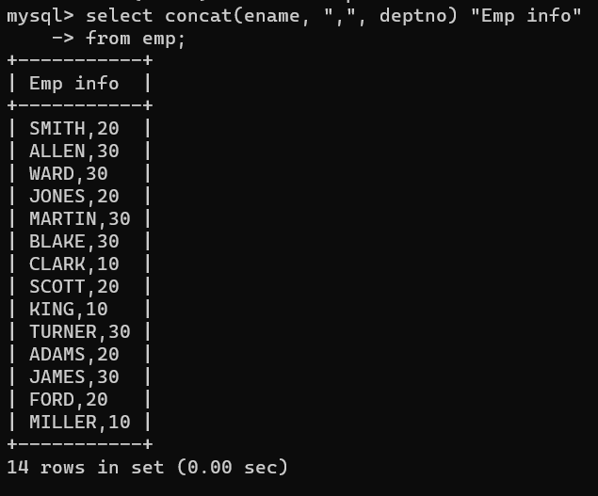

7. Display the emp details who do not have manager.

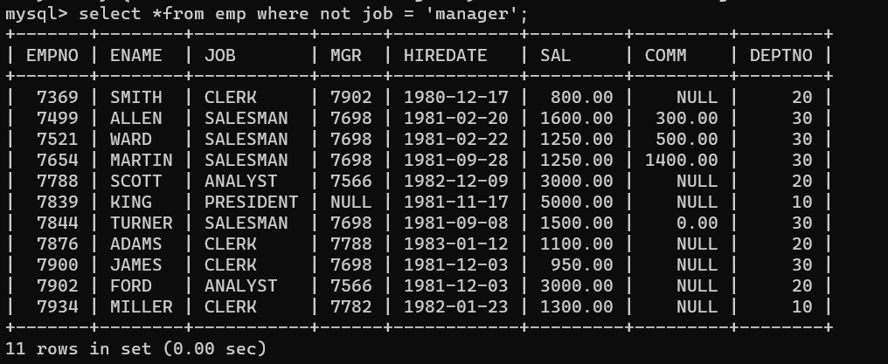

8. Write a query which will display name, department no and date of joining of all employee who were joined between January 1, 1981 and March 31, 1983.

Sort it based on date of joining (ascending).

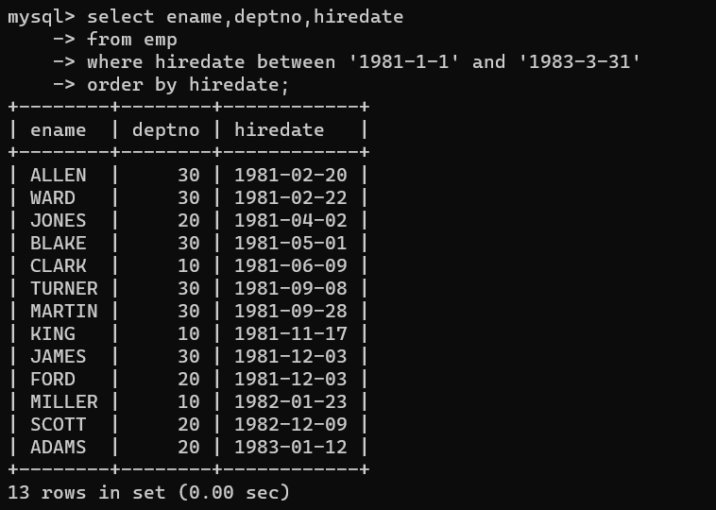

9. Display the employee details where the job contains word ‘AGE’ anywhere in the Job

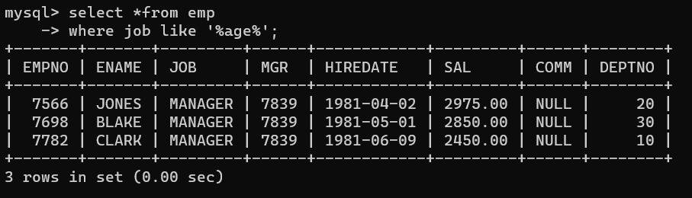

11. List the details of the employee , whose names start with ‘A’ and end with ‘S’ or whose names contains N as the second or third character, and ending with either ‘N’ or ‘S’.

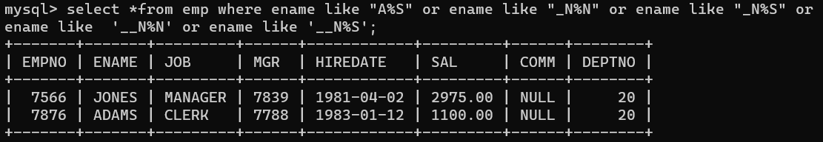

12. List the names of the emp having ‘_’ character in their name.



13. find 3rd highly paid employee

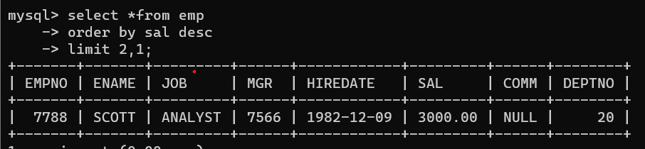

14 find employee who has earned highest commission

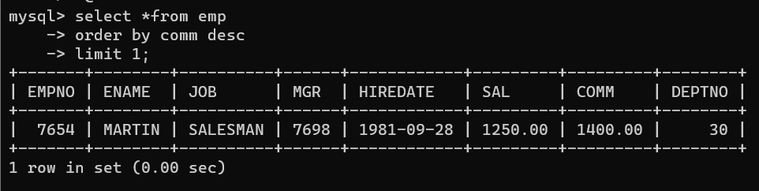

15. display ascii value of 1st character of job from emp

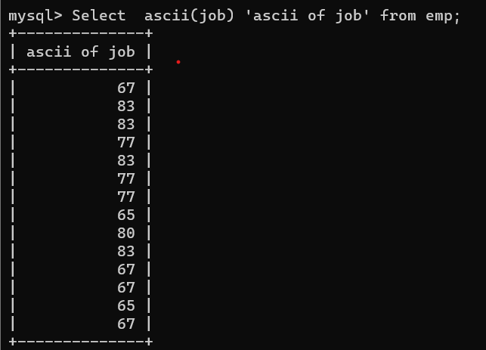

16. display empno,ename,job,code code should be 1 st 3 characters of ename and 1 st 3 characters of job

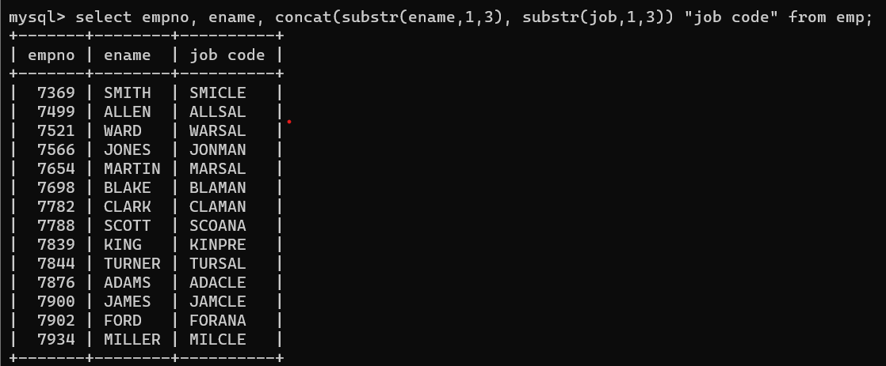

Single Row functions

1. To list all employees and their email, to generate email use 2 to 5 characters from ename Concat it with 2 to 4 characters in job and then concat it with ‘@mycompany.com’

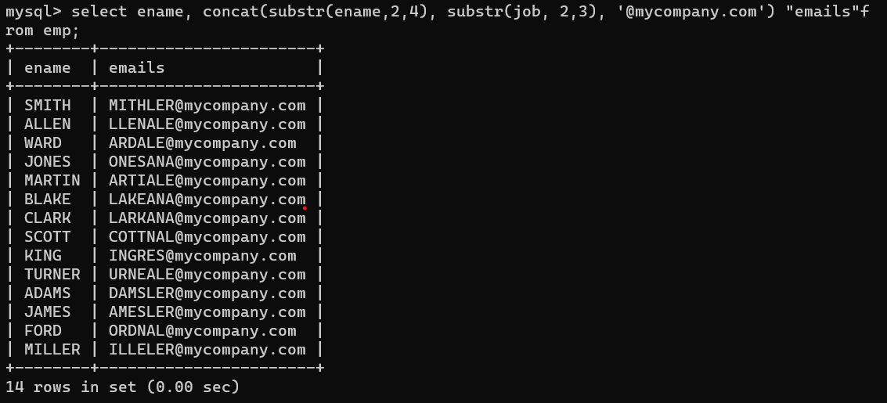

2. List all employees who joined in September.

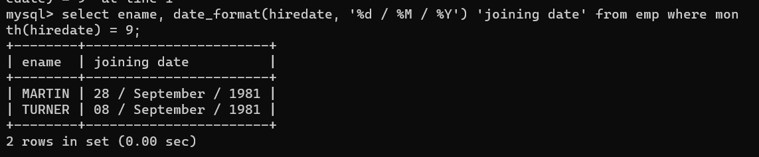

3. List the empno, name, and department number of the emp who have experience of 18 or more years and sort them based on their experience.

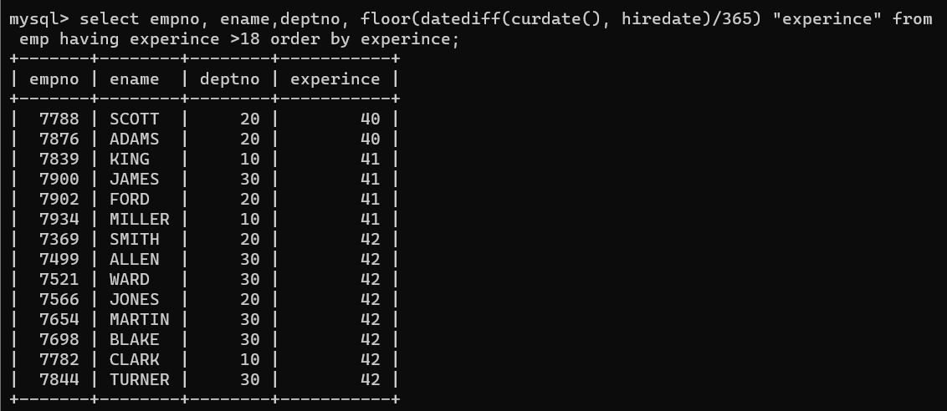

4. Display the employee details who joined on 3rd of any month or any year

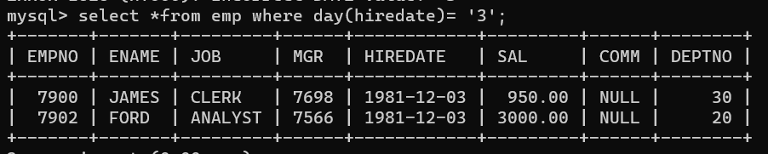

5. display all employees who joined between years 1981 to 1983. Group functions

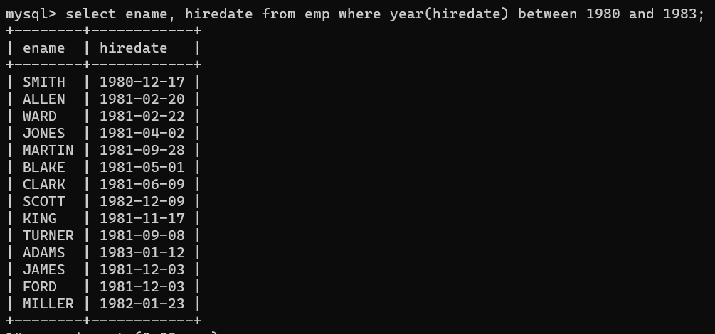

6. Display the Highest, Lowest, Total & Average salary of all employee. Label the columns Maximum, Minimum, Total and Average respectively for each Department. Also round the result to the nearest whole number.

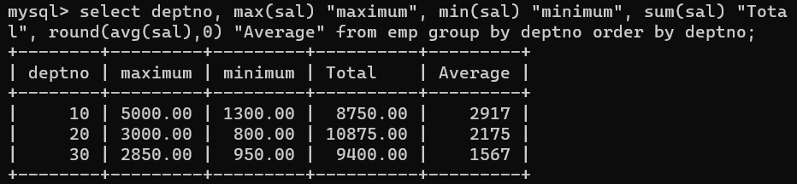

7. Display Department no and number of managers working in that department. Label the column as ‘Total Number of Managers’ for each department.

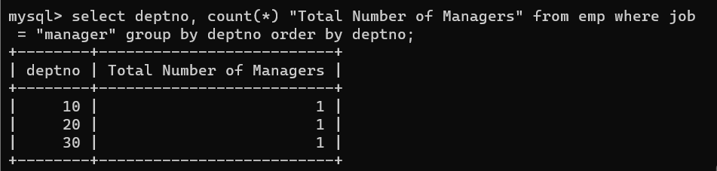

8. Get the Department number, and sum of Salary of all non managers where the sum is greater than 20000



1. Write a query to display the first day of the month (in datetime format) three months before the current month. Sample current date : 2014-09-03 Expected result : 2014-06-01

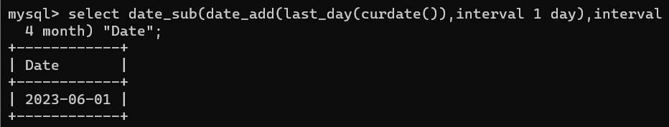

2. Write a query to display the last day of the month (in datetime format) three months before the current month.

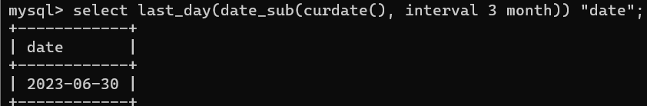

3. Write a query to get the distinct Mondays from hiredate in emp tables.

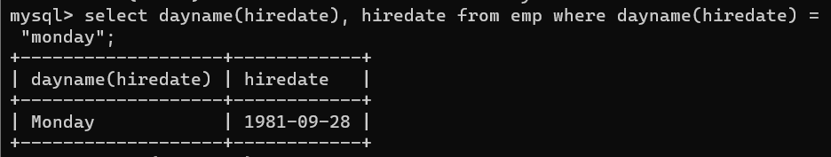

4. Write a query to get the first day of the current year.

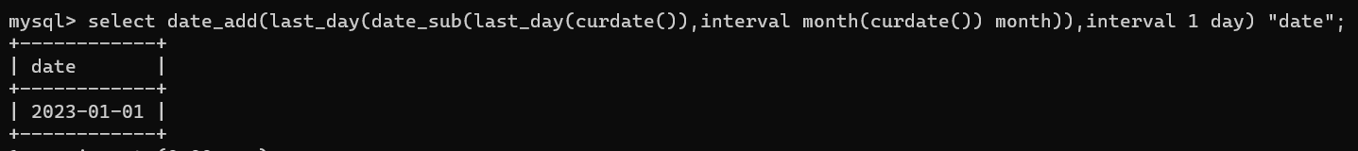

5. Write a query to get the last day of the current year.

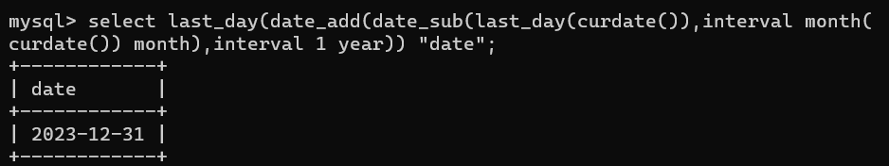

6. Write a query to calculate your age in year.

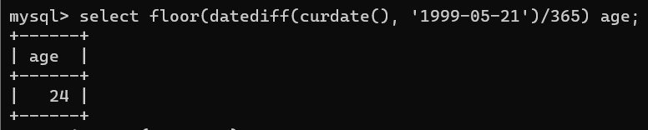

7. Write a query to get the current date in the following format. Sample date : 04-sep-2014 Output : September 4, 2014

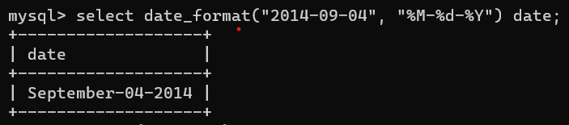

8. Write a query to get the current date in Thursday September 2014 format. Thursday September 2014

9. Write a query to extract the year from the current date.

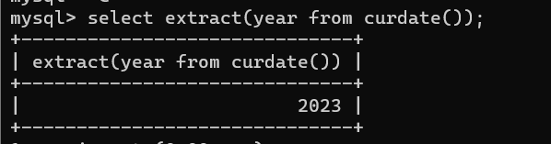

10. Write a query to get the first name and hire date from employees table where hire date between '1987-06-01' and '1987-07-30'



Solve the following

1. write a procedure to insert record into employee table.

the procedure should accept empno, ename, sal, job, hiredate as input parameter

write insert statement inside procedure insert_rec to add one record into table

create procedure insert_rec(peno int,pnm varchar(20),psal decimal(9,2),pjob

varchar(20),phiredate date)

begin

insert into emp(empno,ename,sal,job,hiredate)

values(peno,pnm,psal,pjob,phiredate)

end//

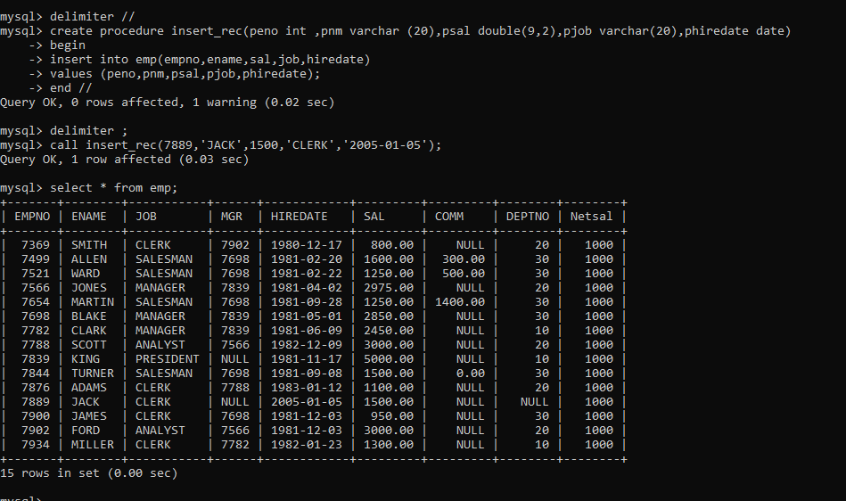

2. write a procedure to delete record from employee table.

the procedure should accept empno as input parameter.

write delete statement inside procedure delete_emp to delete one record from emp

table

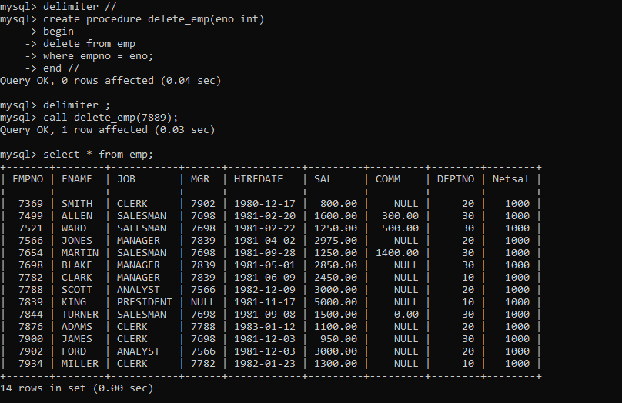

3. write a procedure to display empno,ename,deptno,dname for all employees with sal

> given salary. pass salary as a parameter to procedure

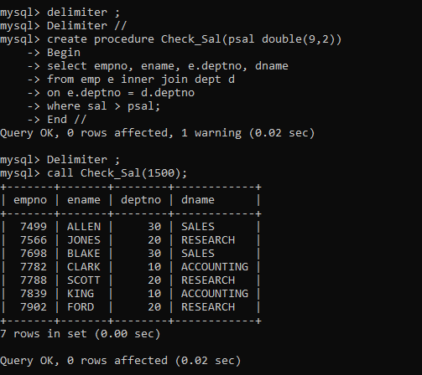

4. write a procedure to find min,max,avg of salary and number of employees in the

given deptno.

deptno --→ in parameter

min,max,avg and count ---→ out type parameter

execute procedure and then display values min,max,avg and count

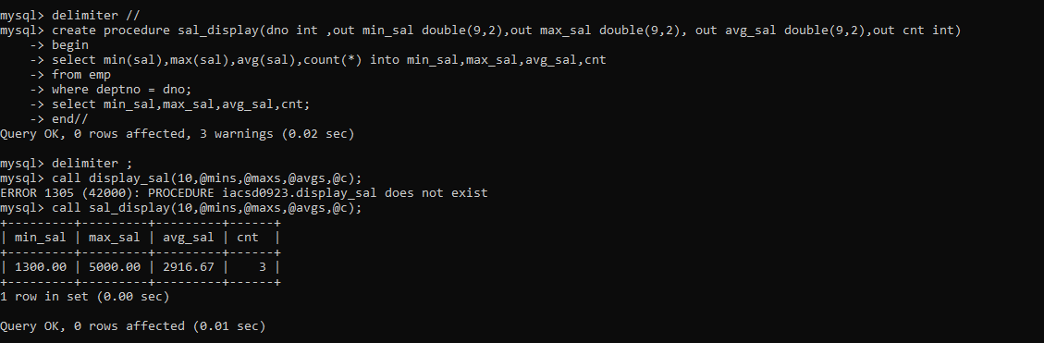

5. write a procedure to display all pid,pname,cid,cname and salesman name(use

product,category and salesman table)

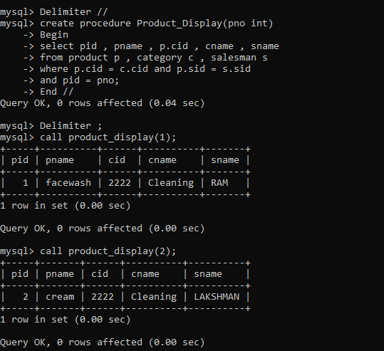

7. Write a procedure that displays the following information of all emp

Empno,Name,job,Salary,Status,deptno

Note: - Status will be (Greater, Lesser or Equal) respective to average salary of their own

department. Display an error message Emp table is empty if there is no matching

record.

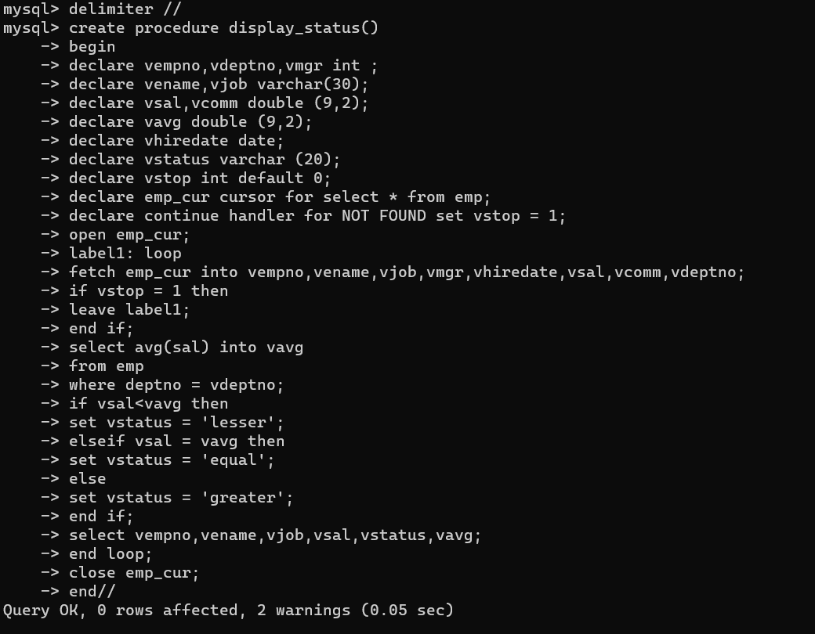

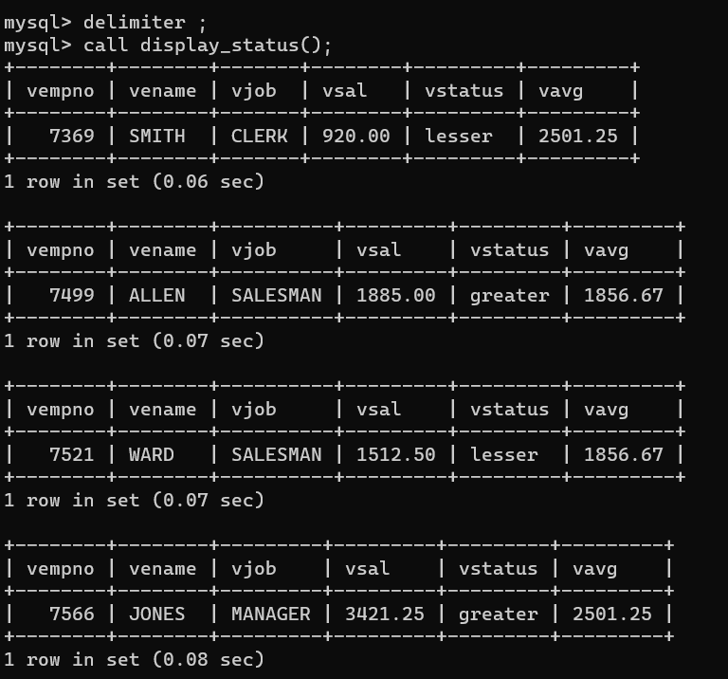

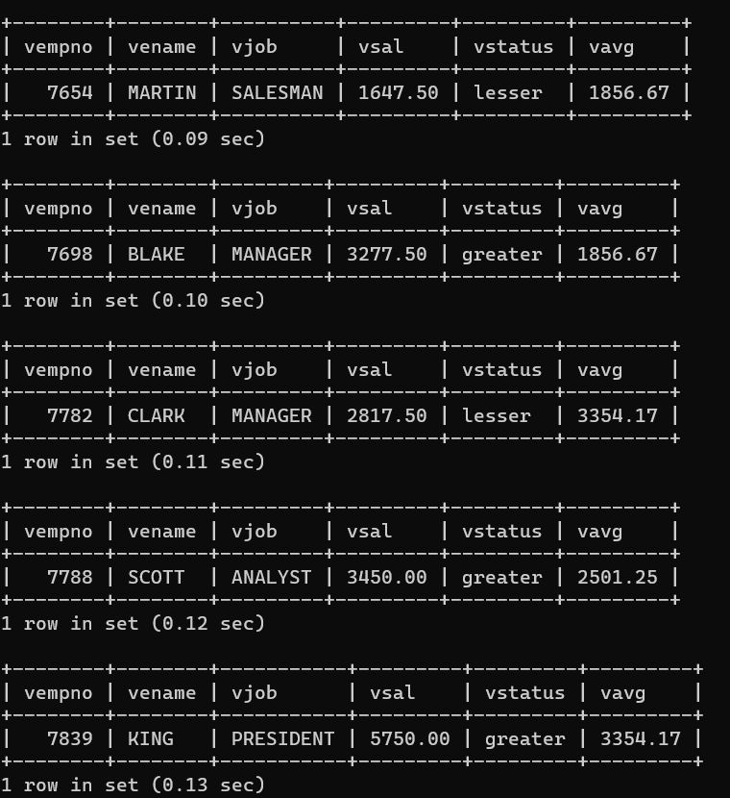

8.

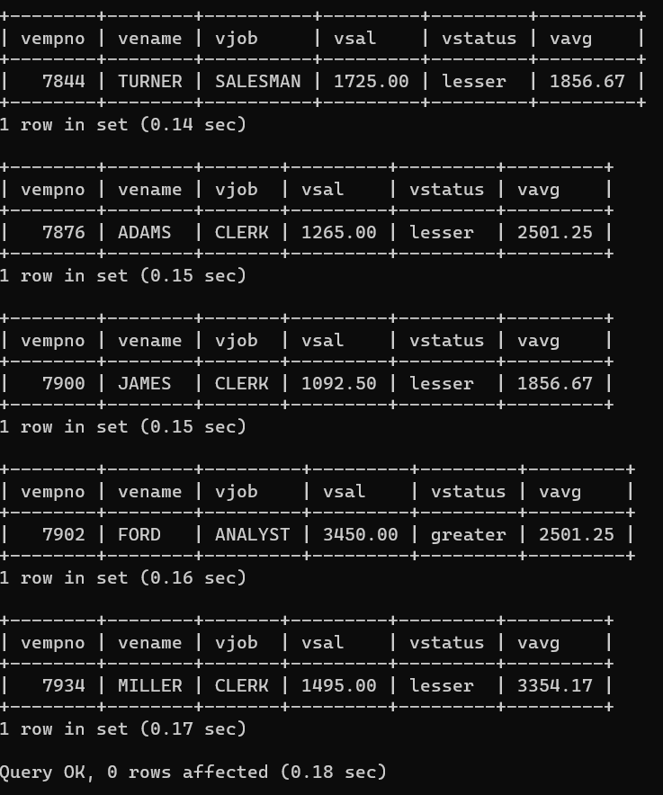

8. Write a procedure to update salary in emp table based on following rules.

Exp< =35 then no Update

Exp> 35 and <=38 then 20% of salary

Exp> 38 then 25% of salary

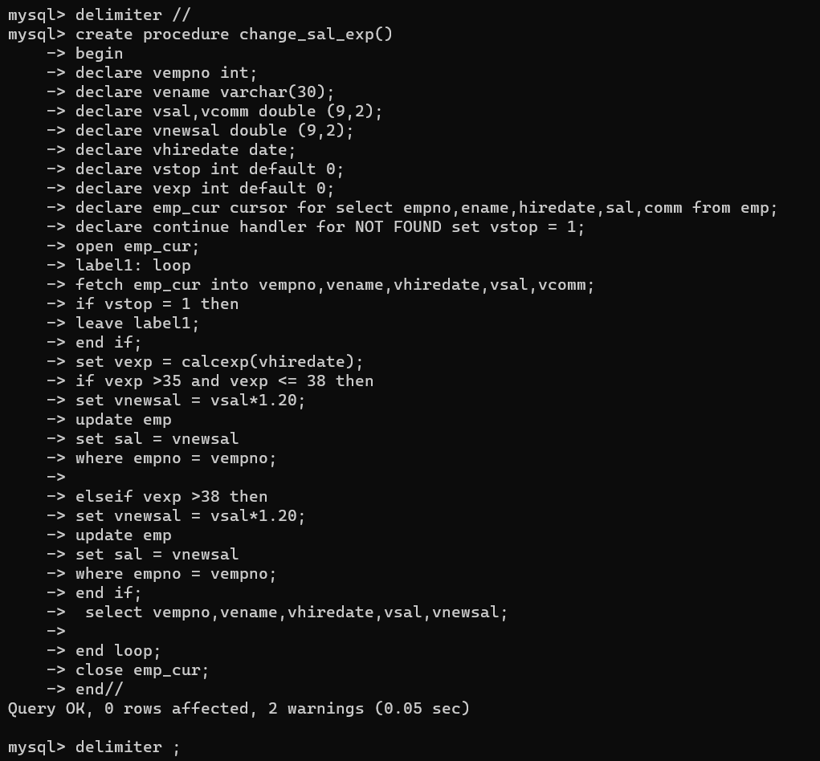

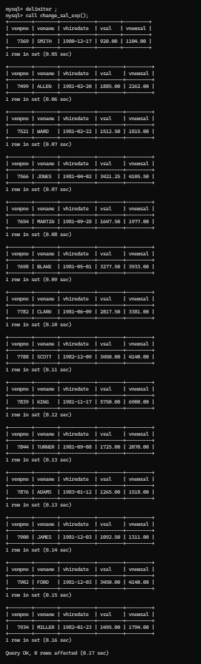

9. Write a procedure and a function.

Function: write a function to calculate number of years of experience of employee.(note:

pass hiredate as a parameter)

Procedure: Capture the value returned by the above function to calculate the additional

allowance for the emp based on the experience.

Additional Allowance = Year of experience x 3000

Calculate the additional allowance

and store Empno, ename,Date of Joining, and Experience in

years and additional allowance in Emp_Allowance table.

create table emp_allowance(

empno int,

ename varchar(20),

hiredate date,

experience int,

allowance decimal(9,2));

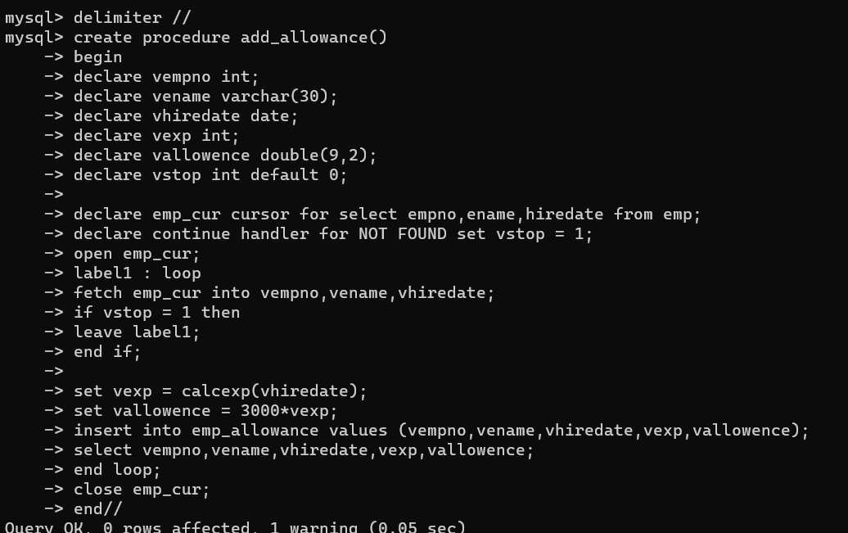

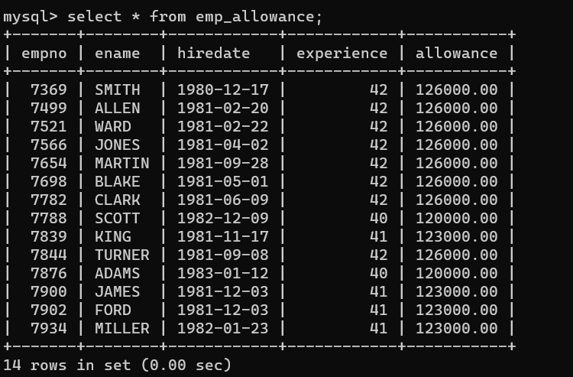

10. Write a function to compute the following. Function should take sal and hiredate

as i/p and return the cost to company.

DA = 15% Salary, HRA= 20% of Salary, TA= 8% of Salary.

Special Allowance will be decided based on the service in the company.

< 1 Year Nil

>=1 Year< 2 Year 10% of Salary

>=2 Year< 4 Year 20% of Salary

>4 Year 30% of Salary

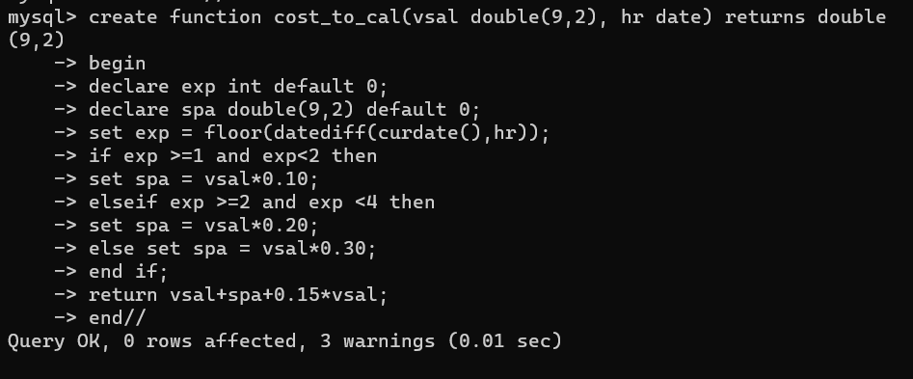

11. Write query to display empno,ename,sal,cost to company for all employees(note:

use function written in question 10)

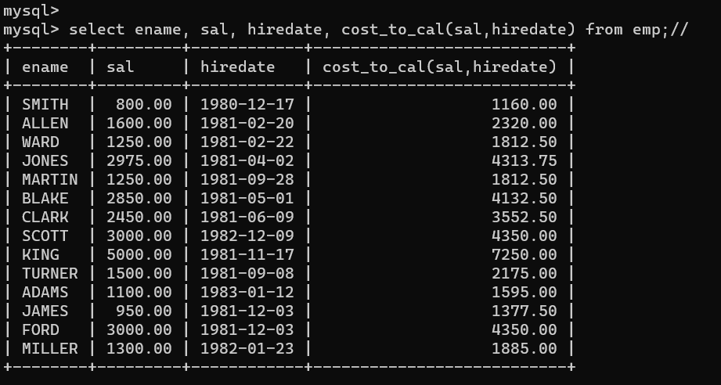

Q2. Write trigger

1. Write a tigger to store the old salary details in Emp _Back (Emp _Back has the

same structure as emp table without any

constraint) table.

(note :create emp_back table before writing trigger)

----- to create emp_back table

create table emp_back(

empno int,

ename varchar(20),

oldsal decimal(9,2),

newsal decimal(9,2)

)

(note :

execute procedure written in Q8 and

check the entries in EMP_back table after execution of the procedure)

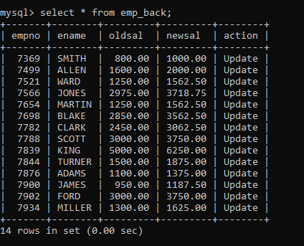

2. Write a trigger which add entry in audit table when user tries to insert or delete

records in employee table store empno,name,username and date on which

operation performed and which action is done insert or delete. in emp_audit table.

create table before writing trigger.

create table empaudit(

empno int;

ename varchar(20),

username varchar(20);

chdate date;

action varchar(20)

);

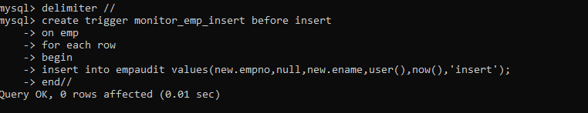

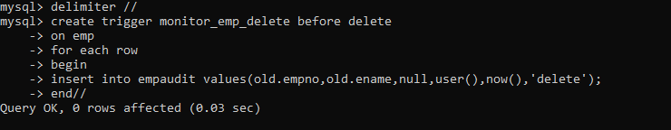

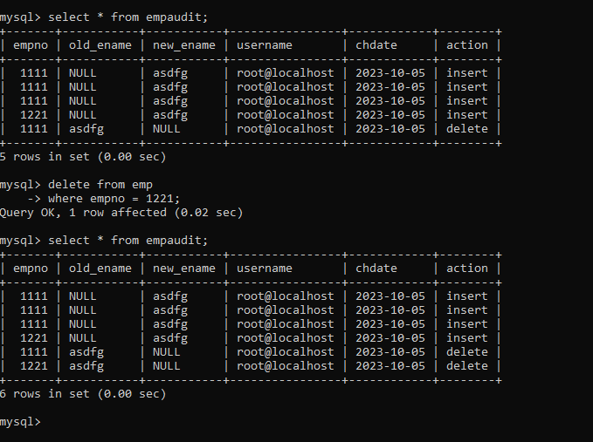

3. Create table vehicle_history. Write a trigger to store old vehicleprice and new vehicle

price in history table before you update price in vehicle table

(note: use vehicle table).

create table vehicle_history(

vno int,

vname varchar(20),

oldprice decimal(9,2),

newprice decimal(9,2),

chdate date,

username varchar(20)

);

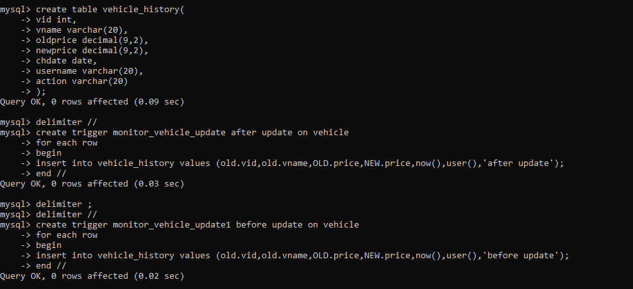

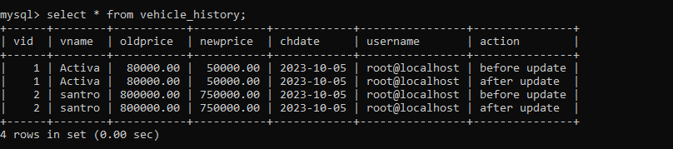

1. Write a MongoDB query to display all the documents in the collection restaurants

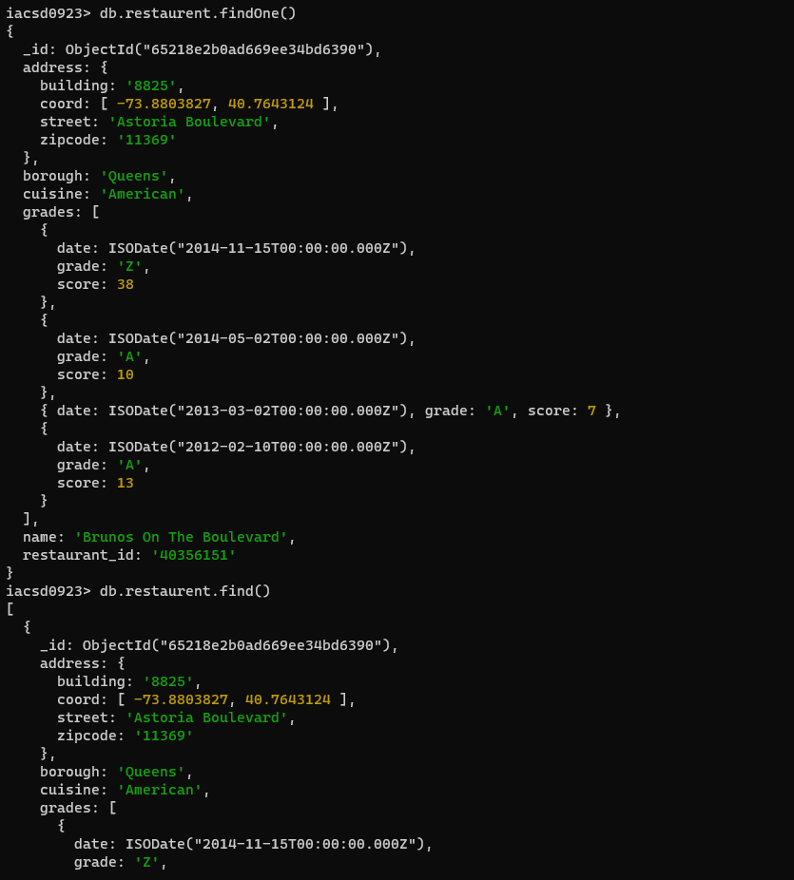

1. Write a MongoDB query to display the fields restaurant_id, name, borough and cuisine for all the documents in the collection restaurant.

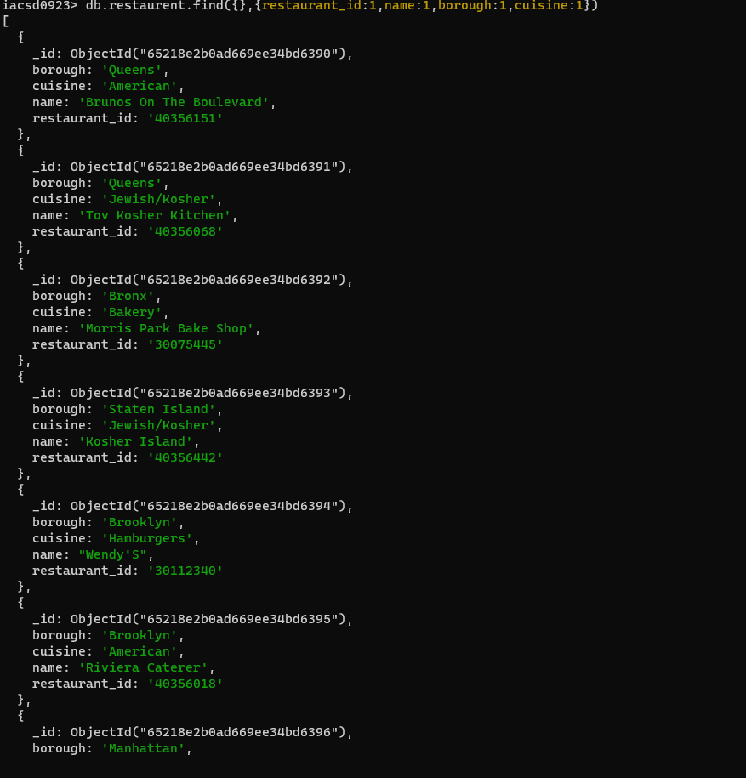

1. Write a MongoDB query to display the fields restaurant_id, name, borough and cuisine, but exclude the field _id for all the documents in the collection restaurant.

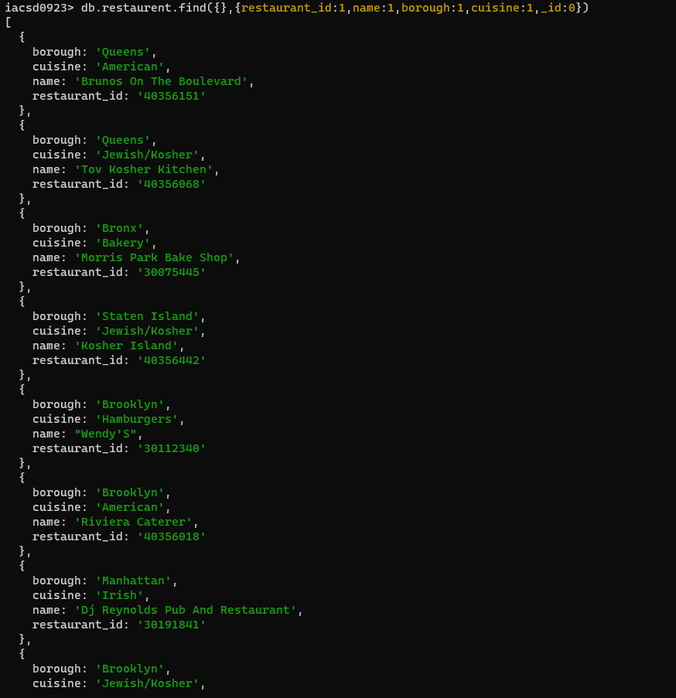

1. Write a MongoDB query to display the fields restaurant_id, name, borough and zip code, but exclude the field _id for all the documents in the collection restaurant.

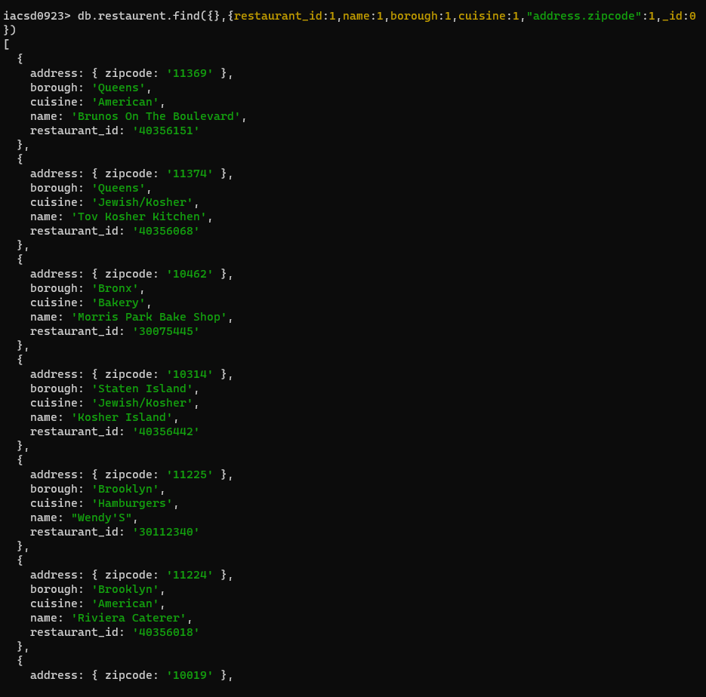

1. Write a MongoDB query to display all the restaurant which is in the borough Bronx

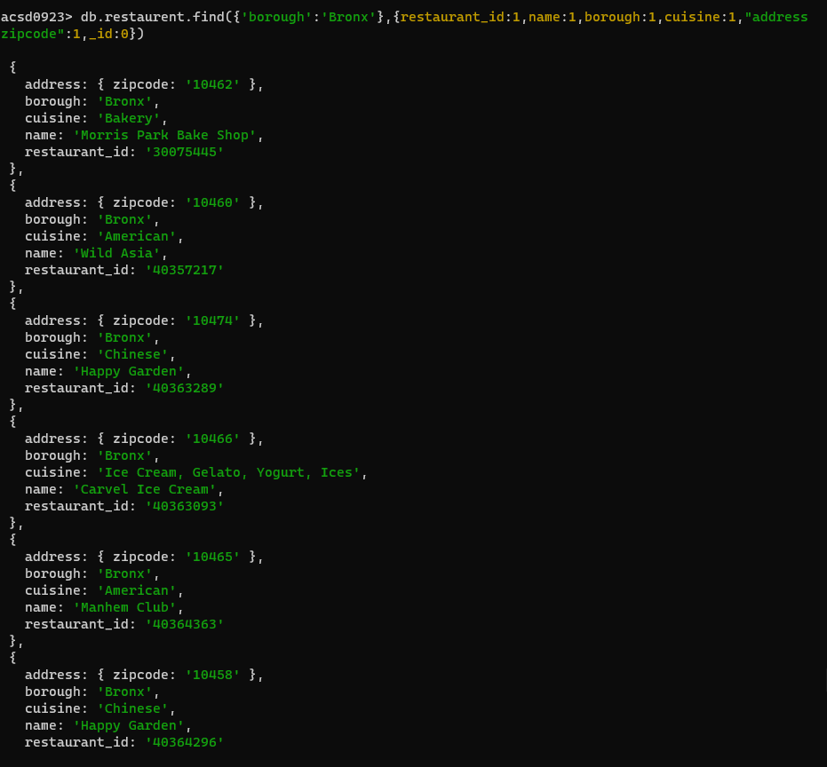

1. Write a MongoDB query to display the first 5 restaurant which is in the borough Bronx.

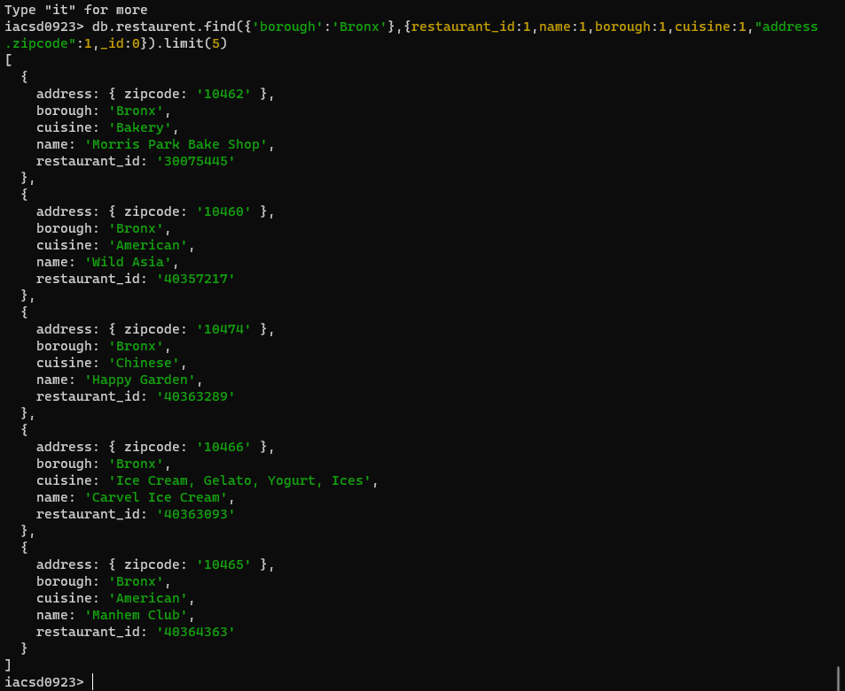

7.Write a MongoDB query to display the next 5 restaurants after skipping first 5 which are in the borough Bronx.

1. Write a MongoDB query to find the restaurants who achieved a score more than 90.

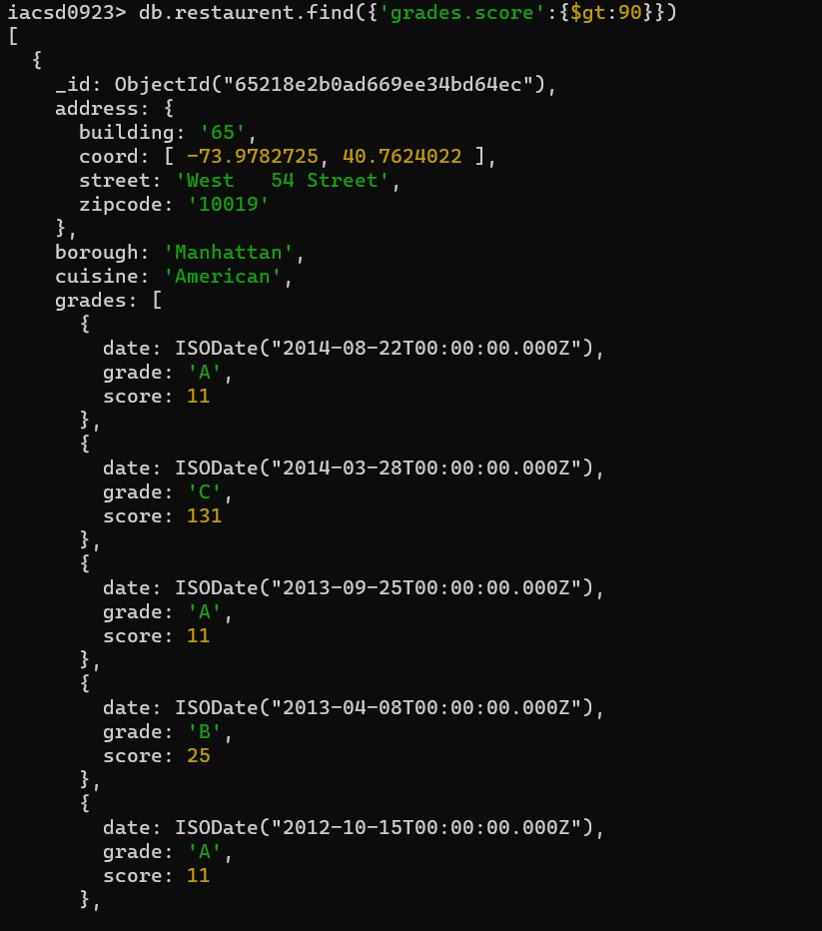

1. Write a MongoDB query to find the restaurants that achieved a score, more than 80 but less than 100.

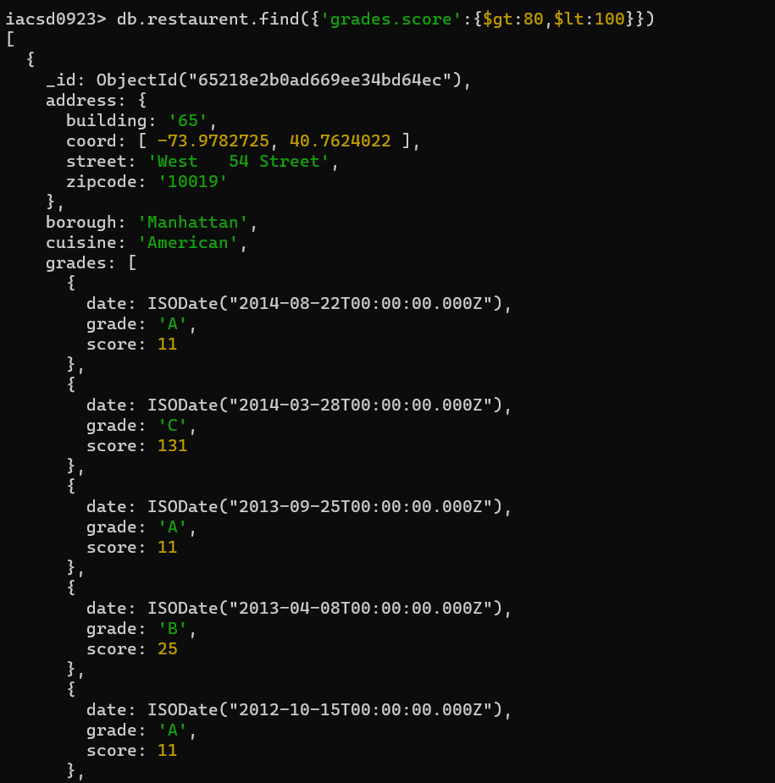

1. Write a MongoDB query to find the restaurants which locate in latitude value less than -

95.754168.

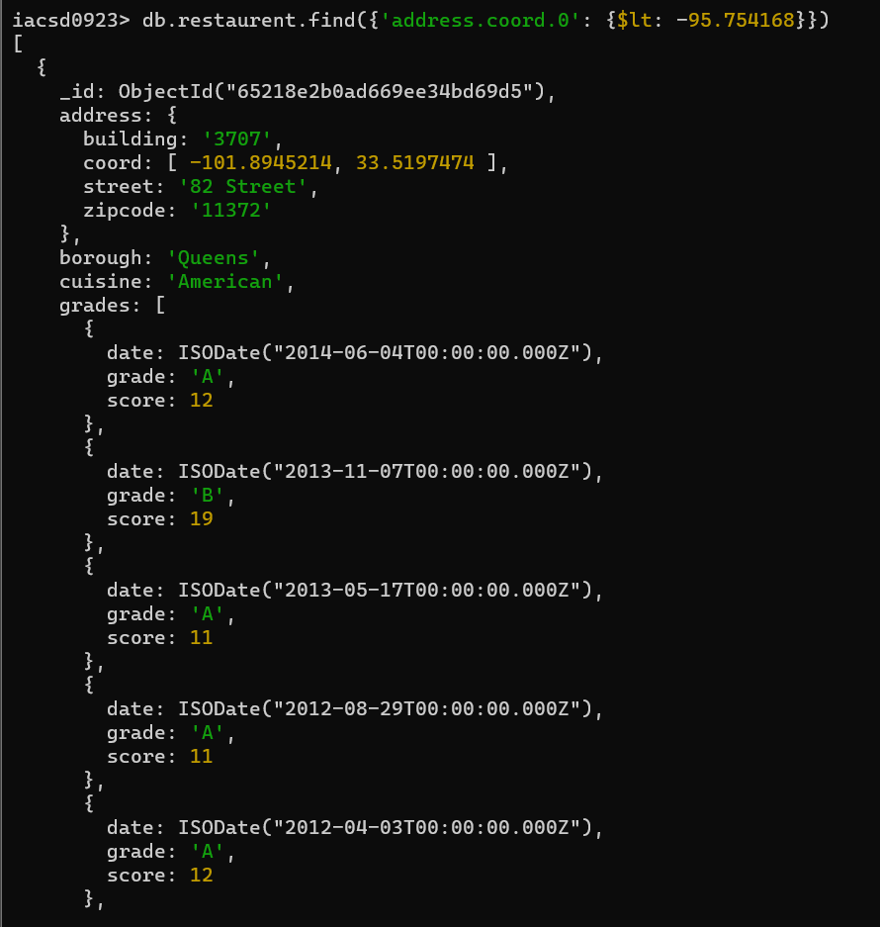

1. Write a MongoDB query to find the restaurants that do not prepare any cuisine of 'American' and their grade score more than 70 and latitude less than -65.754168.

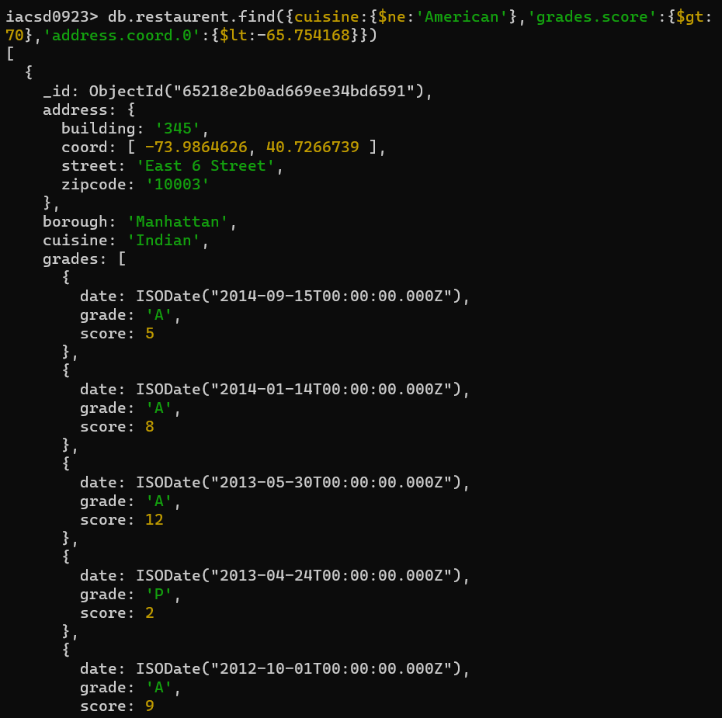

1. Write a MongoDB query to find the restaurants which do not prepare any cuisine of 'American' and achieved a score more than 70 and located in the longitude less than 65.754168.

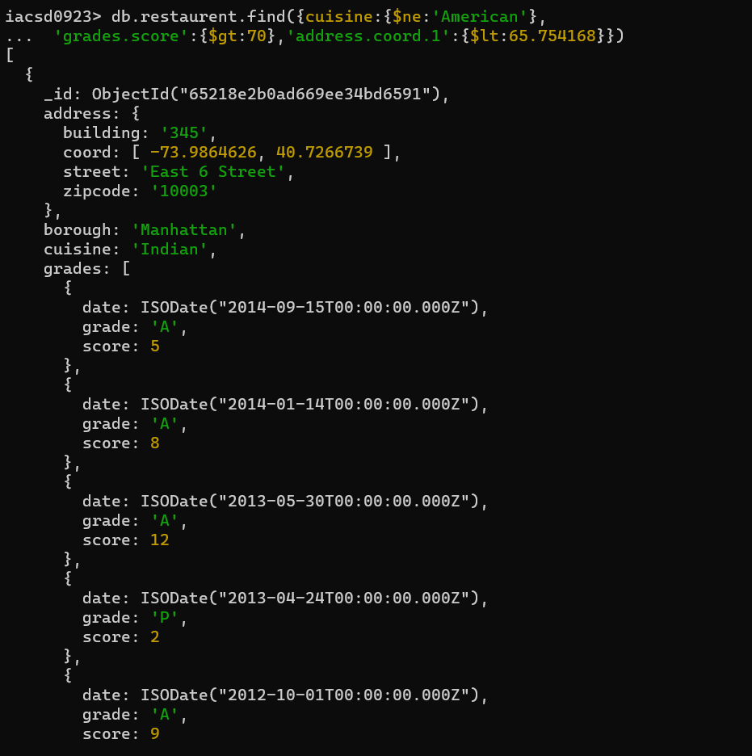

1. Write a MongoDB query to find the restaurants which do not prepare any cuisine of 'American ' and achieved a grade point 'A' not belongs to the borough Brooklyn. The document must be displayed according to the cuisine in descending order.

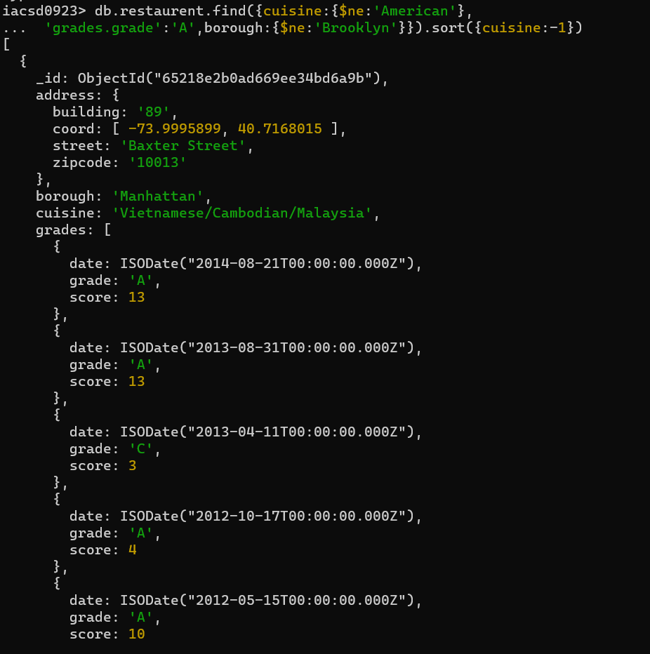

1. Write a MongoDB query to find the restaurant Id, name, borough and cuisine for those restaurants which contain 'Wil' as first three letters for its name.

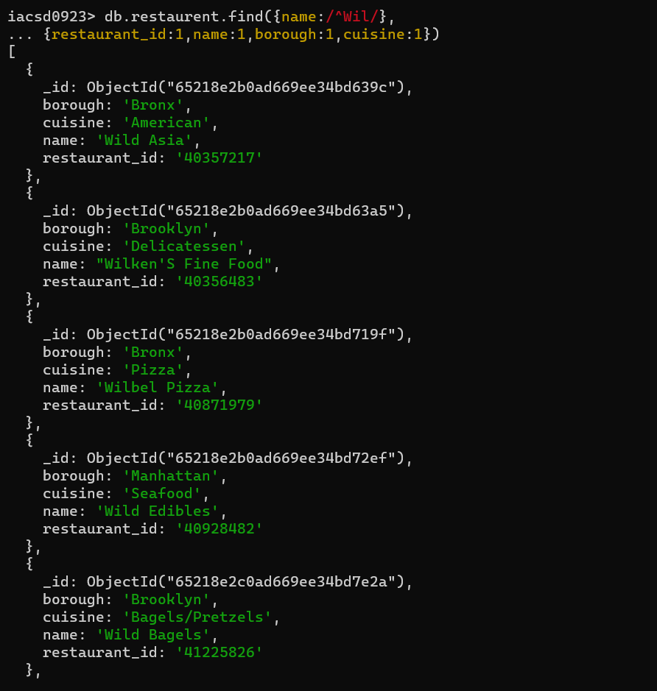

1. Write a MongoDB query to find the restaurant Id, name, borough and cuisine for those restaurants which contain 'ces' as last three letters for its name.

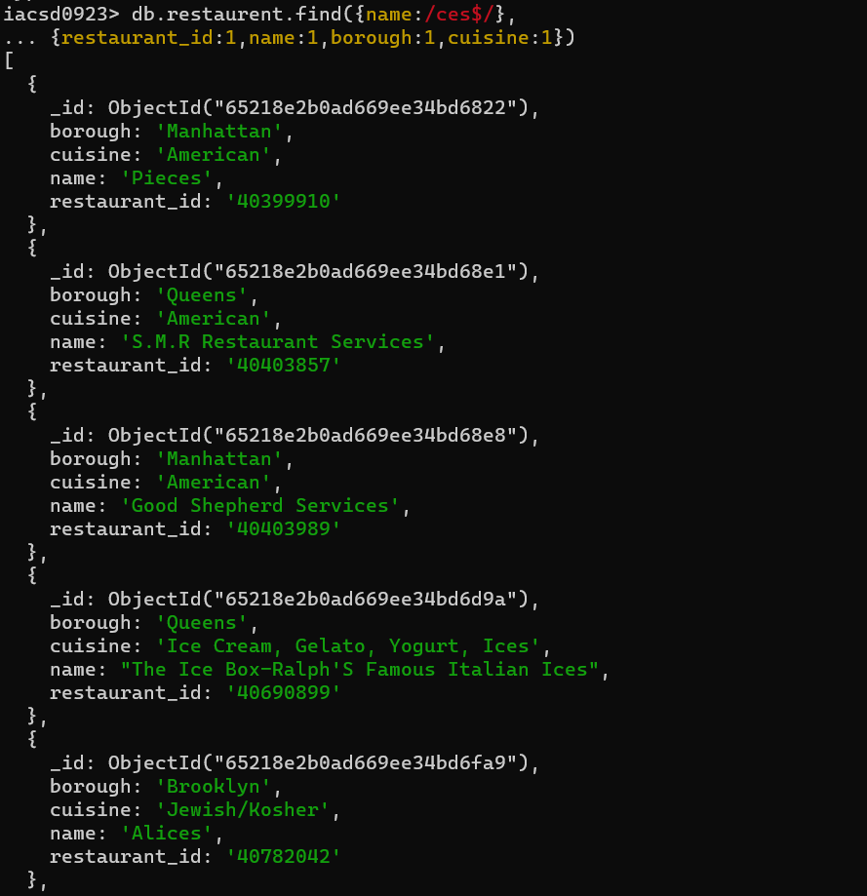

1. Write a MongoDB query to find the restaurant Id, name, borough and cuisine for those restaurants which contain 'Reg' as three letters somewhere in its name.

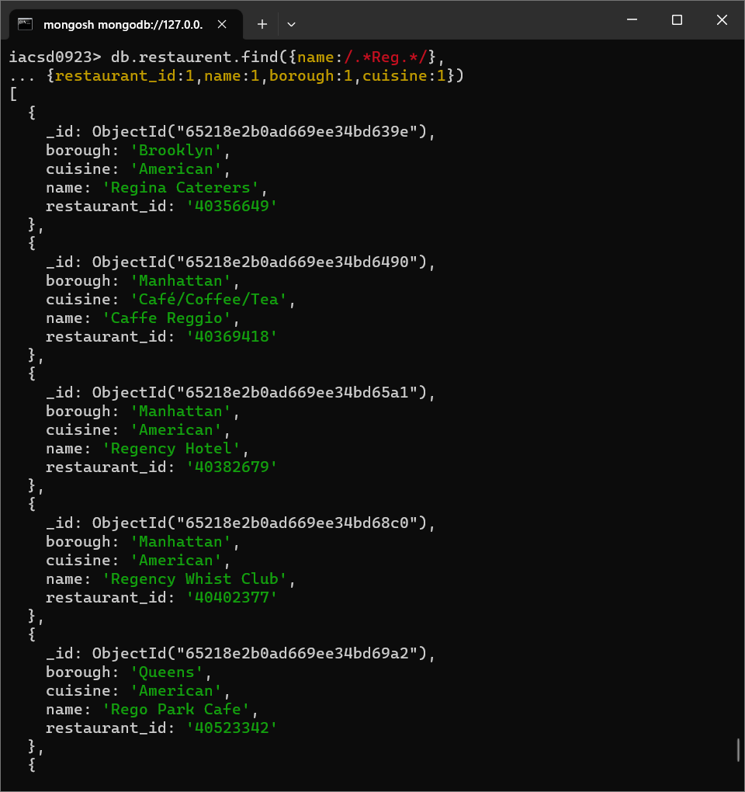

1. Write a MongoDB query to find the restaurants which belong to the borough Bronx and prepared either American or Chinese dish.

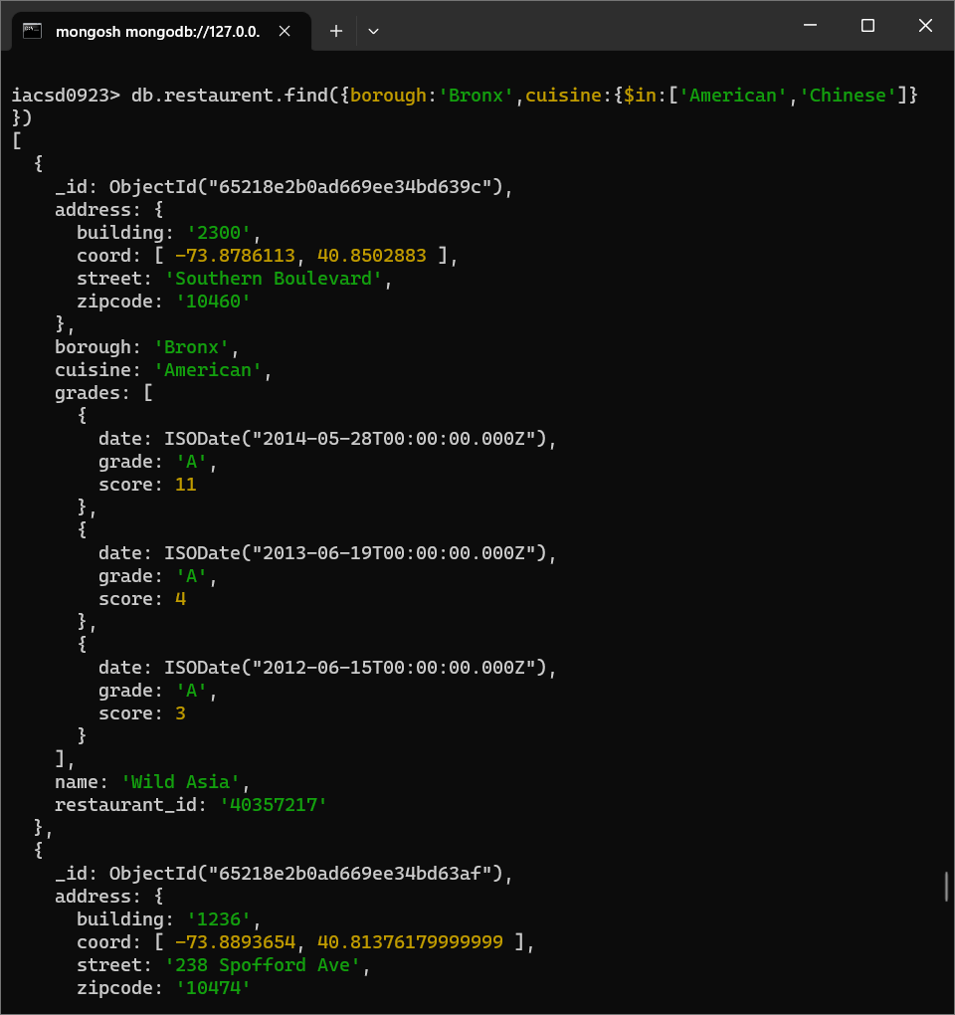

1. Write a MongoDB query to find the restaurant Id, name, borough and cuisine for those restaurants which belong to the borough Staten Island or Queens or Bronxor Brooklyn.

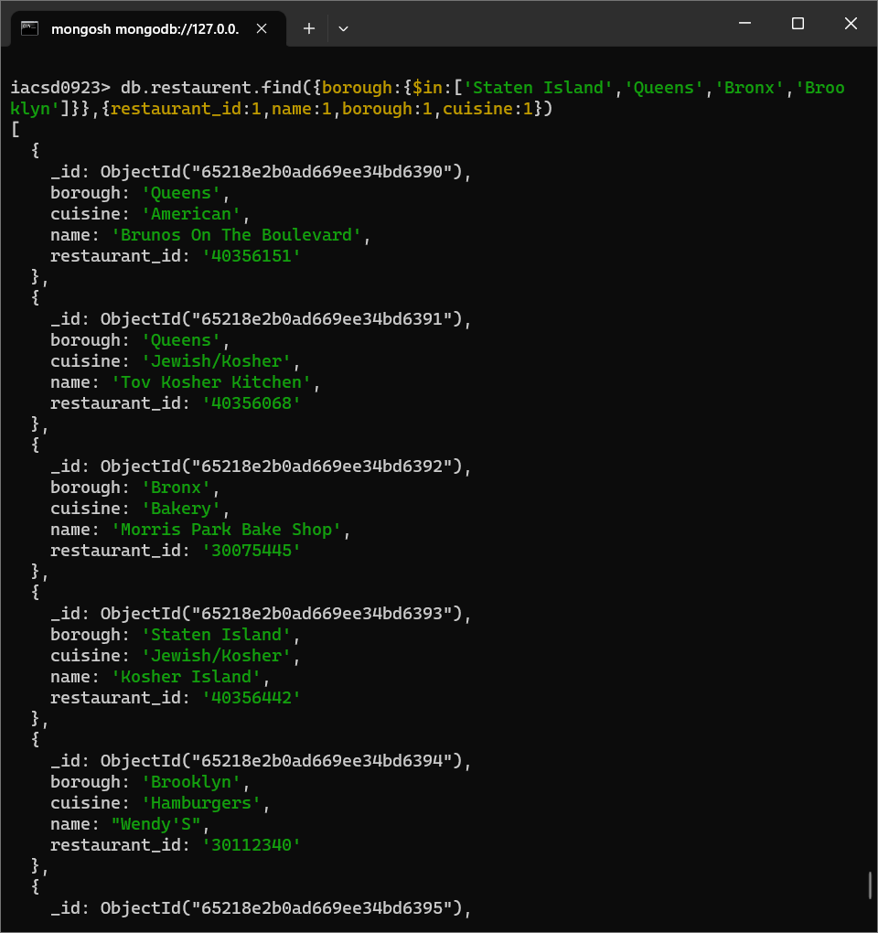

1. Write a MongoDB query to find the restaurant Id, name, borough and cuisine for those restaurants which are not belonging to the borough Staten Island or Queens or Bronxor Brooklyn.

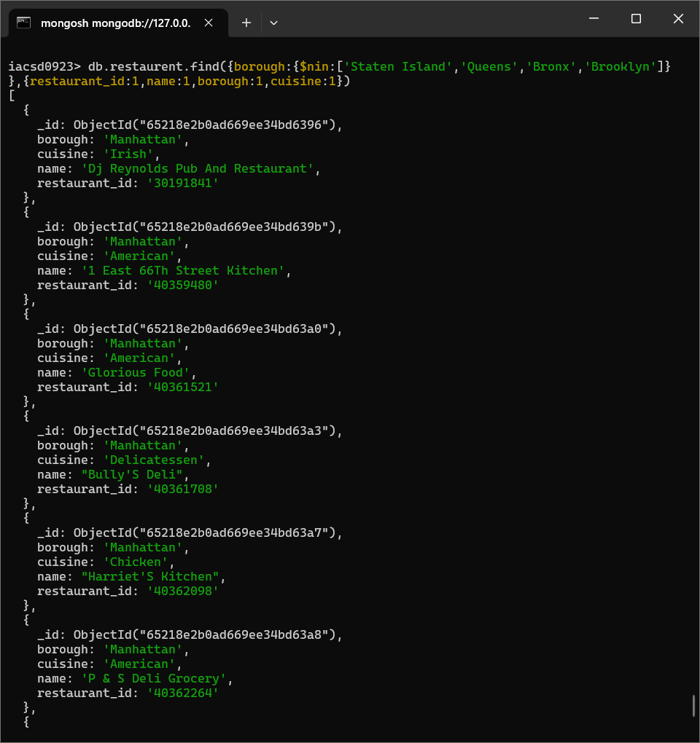

1. Write a MongoDB query to find the restaurant Id, name, borough and cuisine for those restaurants which achieved a score which is not more than 10.

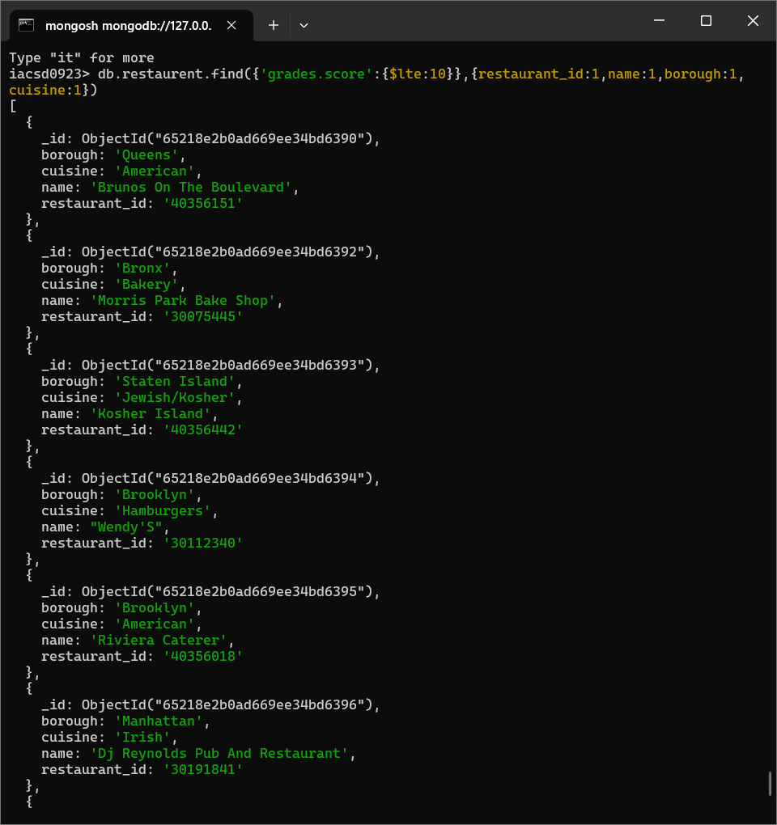

1. Write a MongoDB query to find the restaurant Id, name, borough and cuisine for those restaurants which prepared dish except 'American' and 'Chinees' or restaurant's name begins with letter 'Wil'.

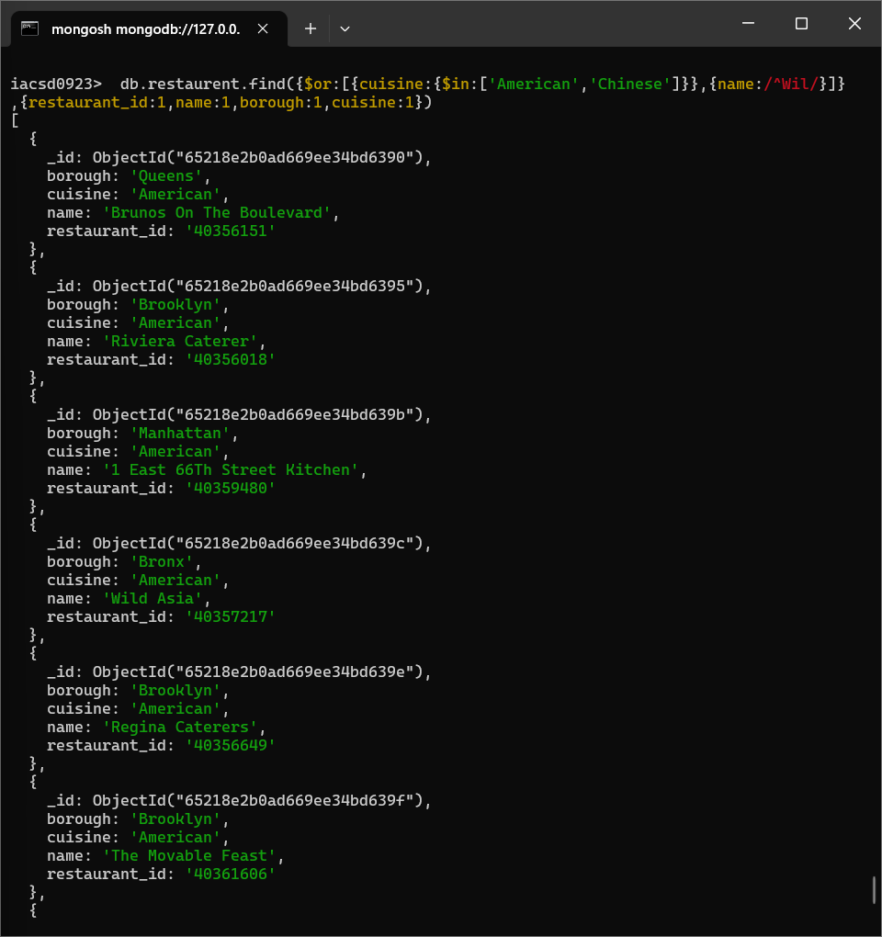

1. Write a MongoDB query to find the restaurant Id, name, and grades for those restaurants which achieved a grade of "A" and scored 11 on an ISODate "2014-08-11T00:00:00Z" among many of survey dates

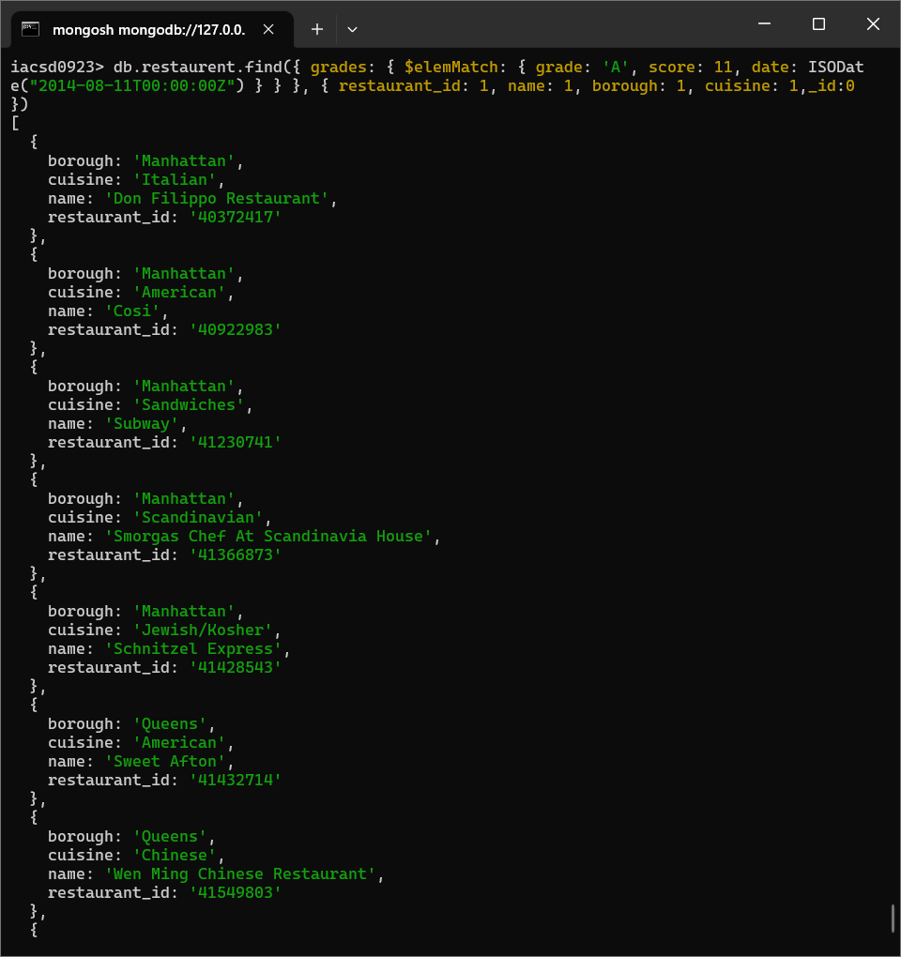

1. Write a MongoDB query to find the restaurant Id, name and grades for those restaurants where the 2nd element of grades array contains a grade of "A" and score 9 on an ISODate "2014-08-11T00:00:00Z".

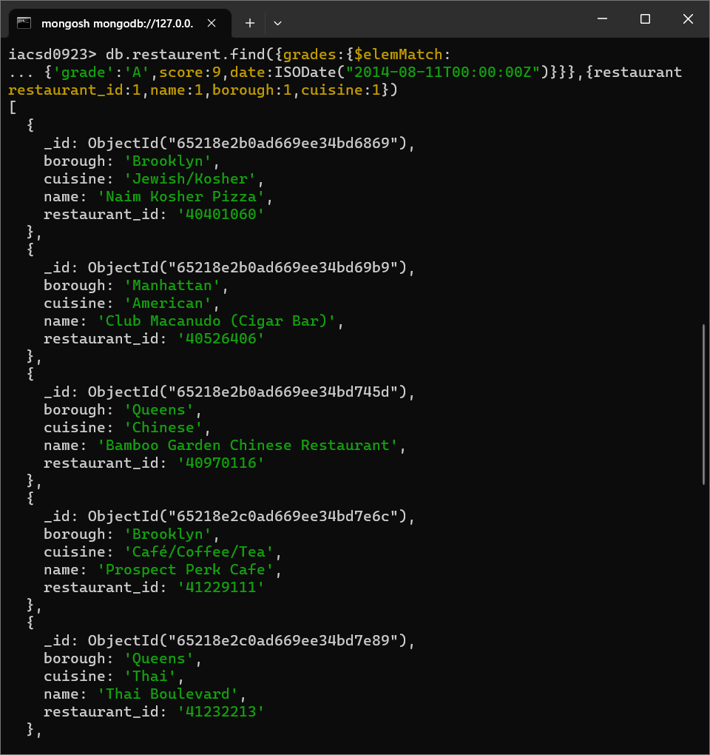

1. Write a MongoDB query to find the restaurant Id, name, address and geographical location for those restaurants where 2nd element of coord array contains a value which is more than 42 and upto 52

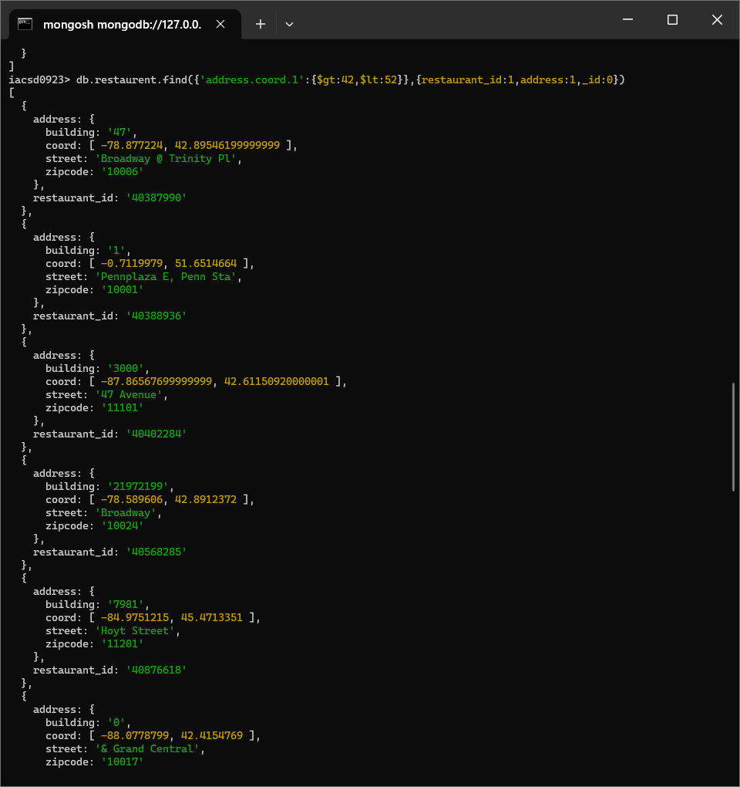

1. Write a MongoDB query to arrange the name of the restaurants in ascending order along with all the columns.

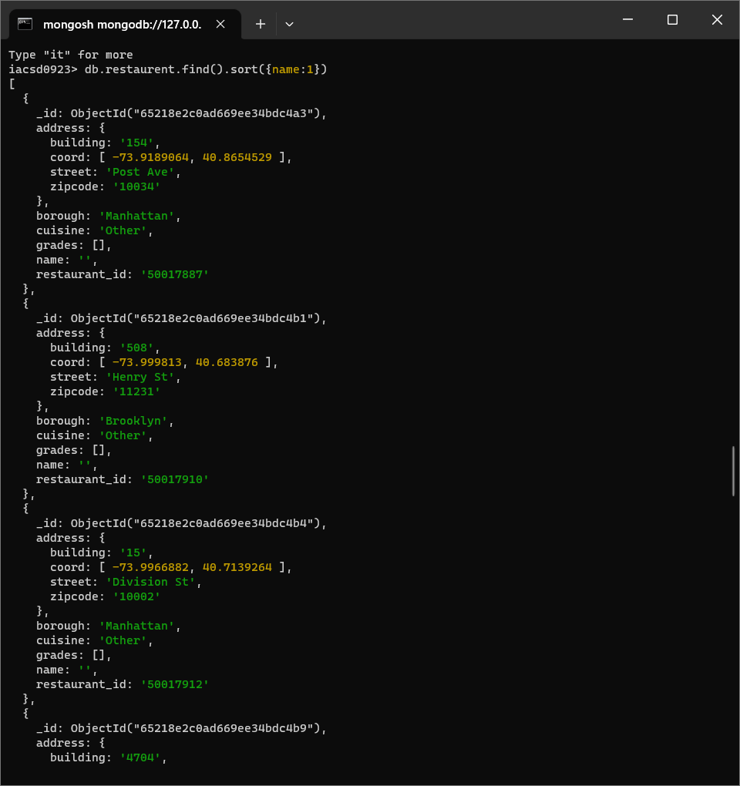

1. Write a MongoDB query to arrange the name of the restaurants in descending along with all the columns.

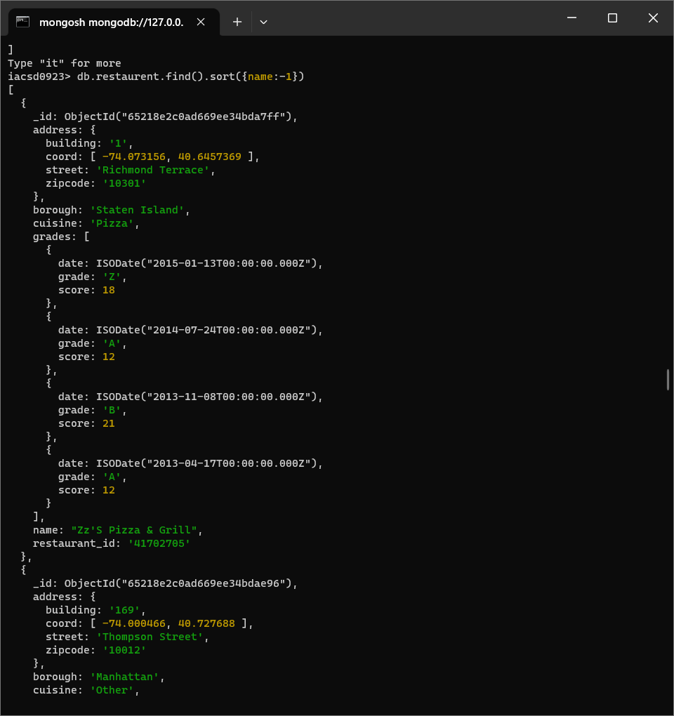

1. Write a MongoDB query to arranged the name of the cuisine in ascending order and for that same cuisine borough should be in descending order.

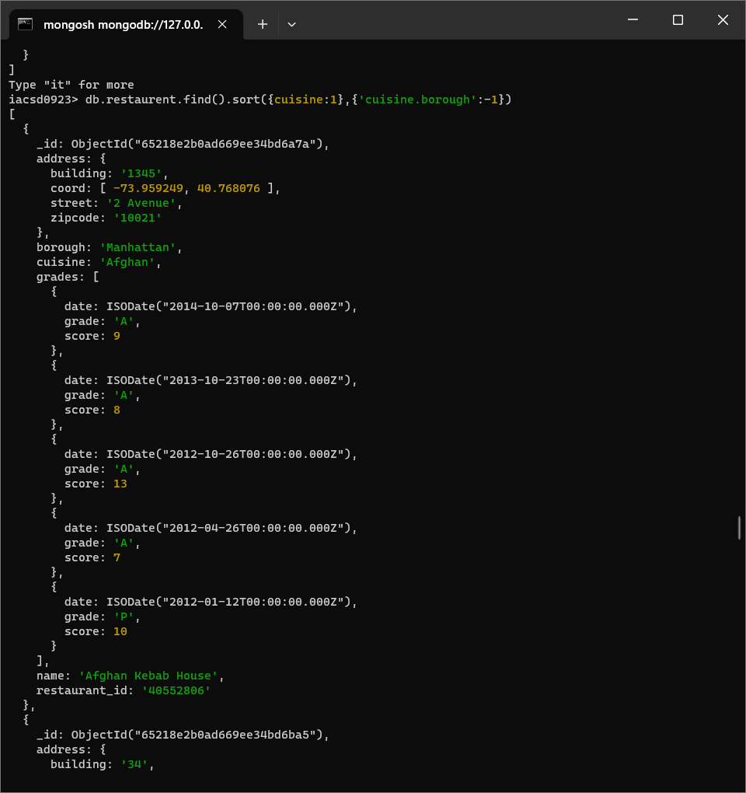

1. Write a MongoDB query to know whether all the addresses contains the street or not.

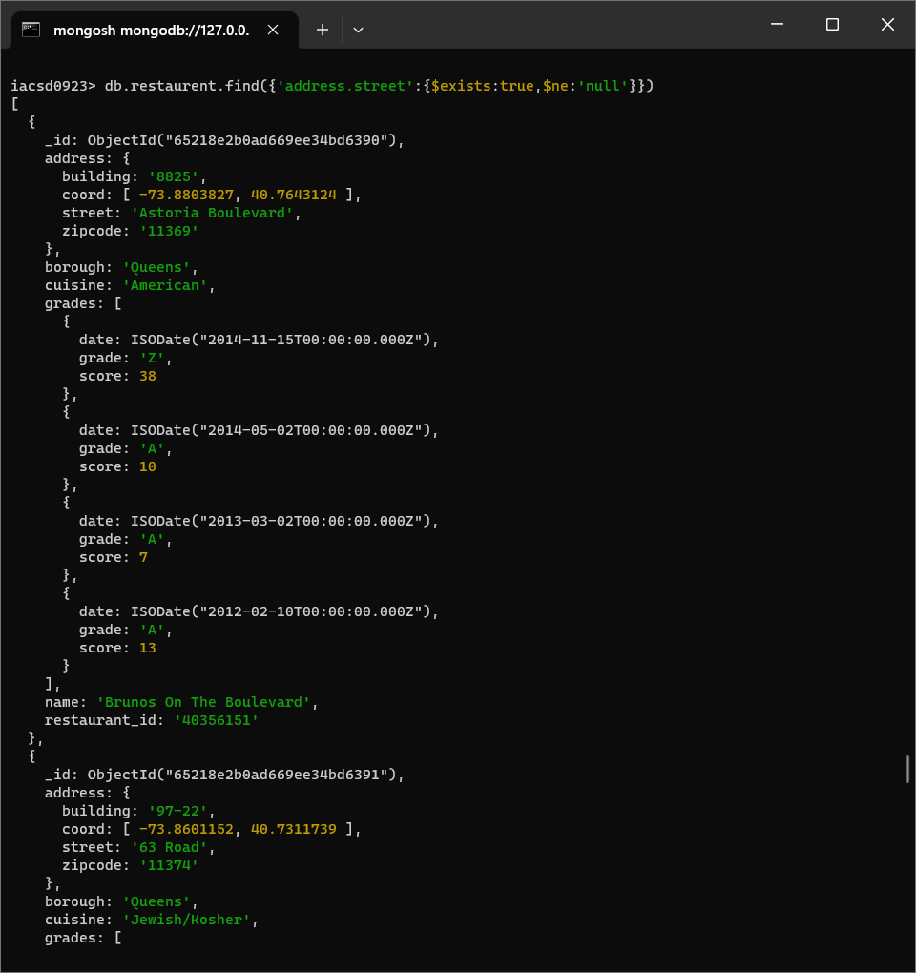

1. Write a MongoDB query which will select all documents in the restaurants collection where the coord field value is Double.

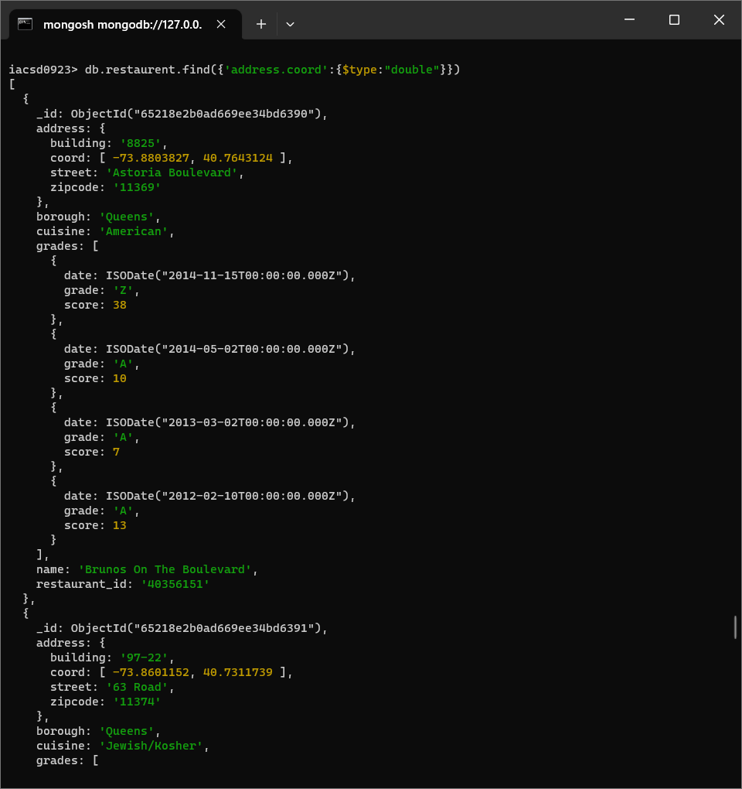

1. Write a MongoDB query which will select the restaurant Id, name and grades for those restaurants which returns 0 as a remainder after dividing the score by 7.

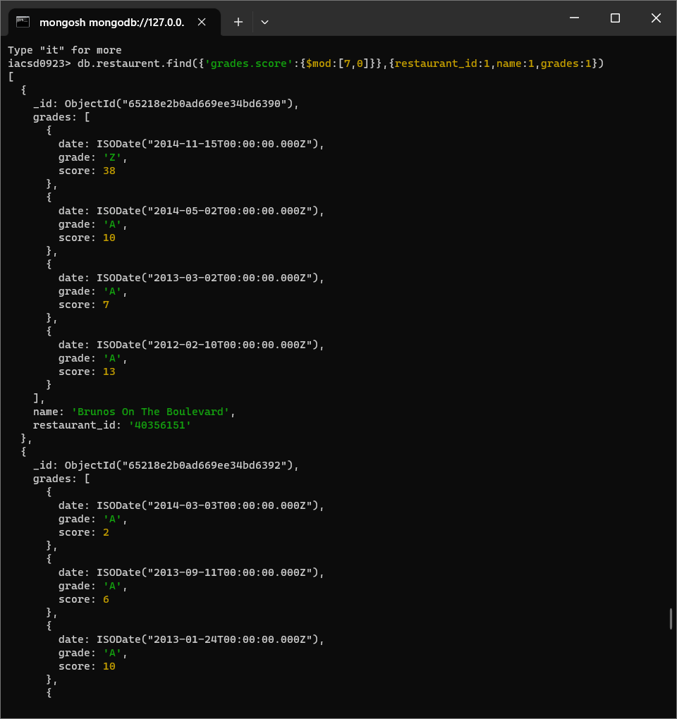

1. Write a MongoDB query to find the restaurant name, borough, longitude and attitude and cuisine for those restaurants which contains 'mon' as three letters somewhere in its name.

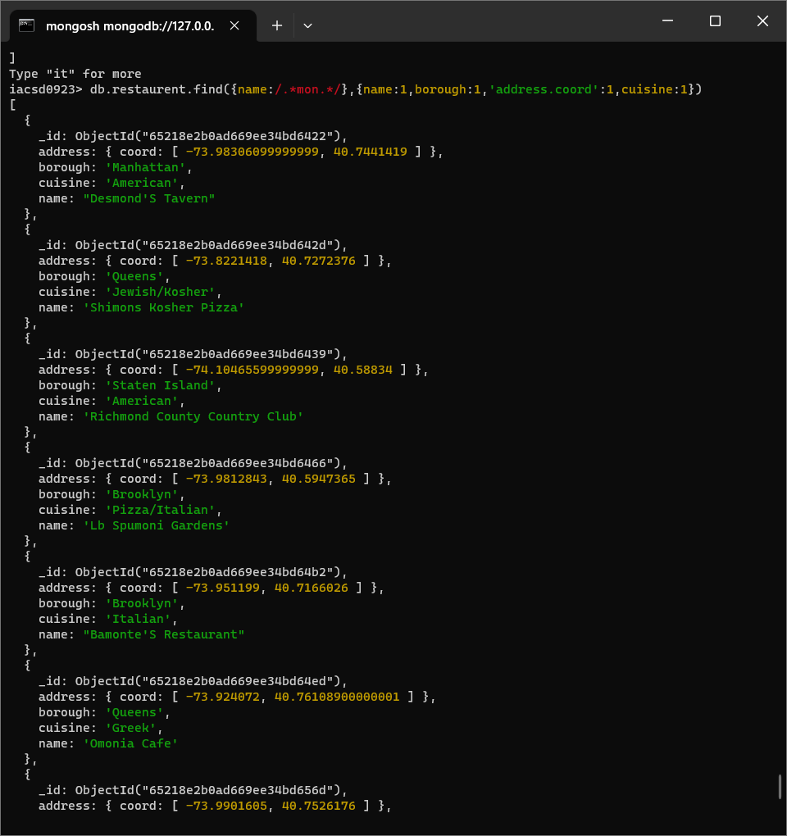

1. Write a MongoDB query to find the restaurant name, borough, longitude and latitude and cuisine for those restaurants which contain 'Mad' as first three letters of its name.

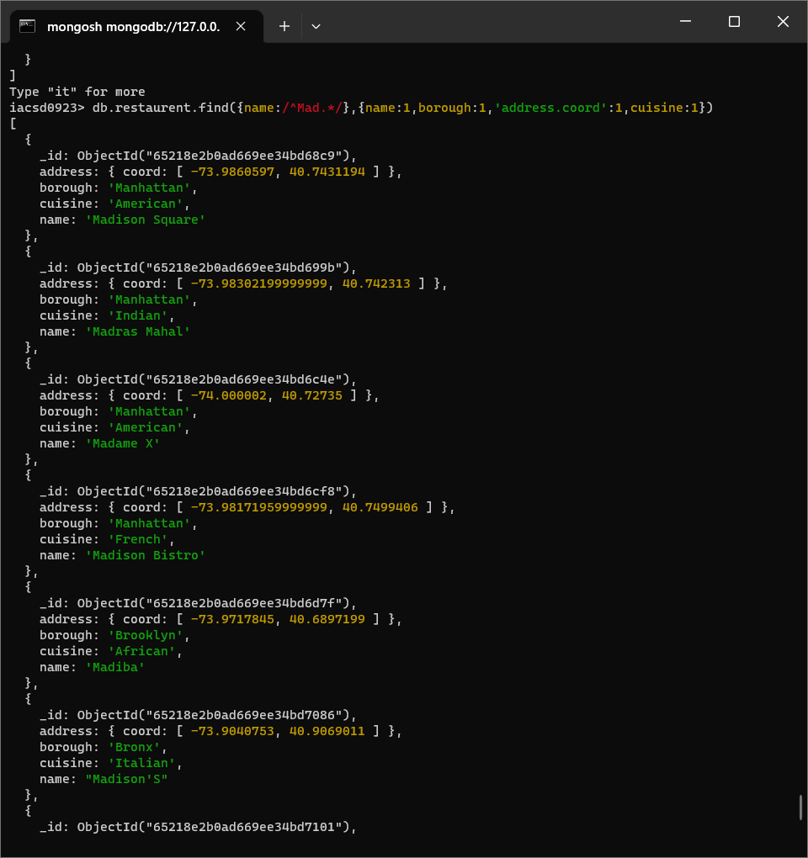

**Database Assignment 8: MongoDB**

Create a Employee Collection add 5 documents: Example:

{empno:111,ename:”Deepali

Vaidya”,sal:40000.00,dept:{deptno12,dname:,”Hr”,dloc:”Mumbai},

Desg:”Analyst”,mgr:{name:”Satish”,num:111},project:[{name:”Project-

1”,Hrs:4},{name:”project- 2”,Hrs:4}]}

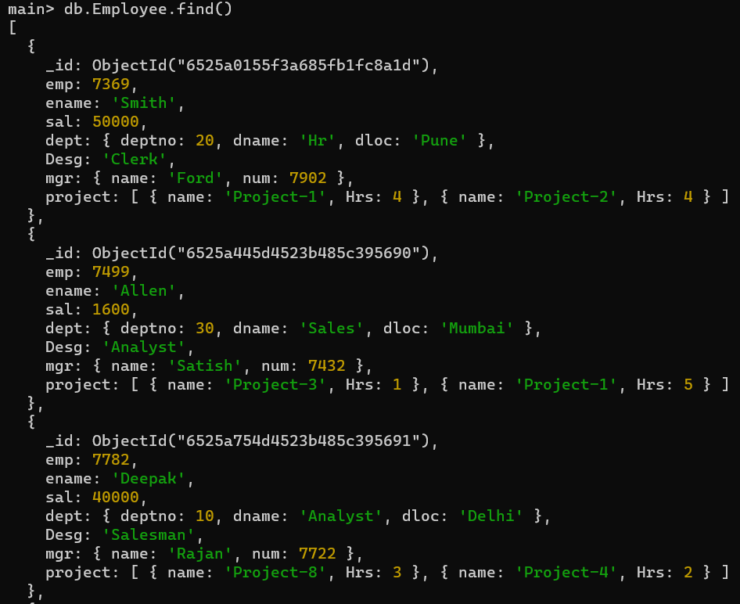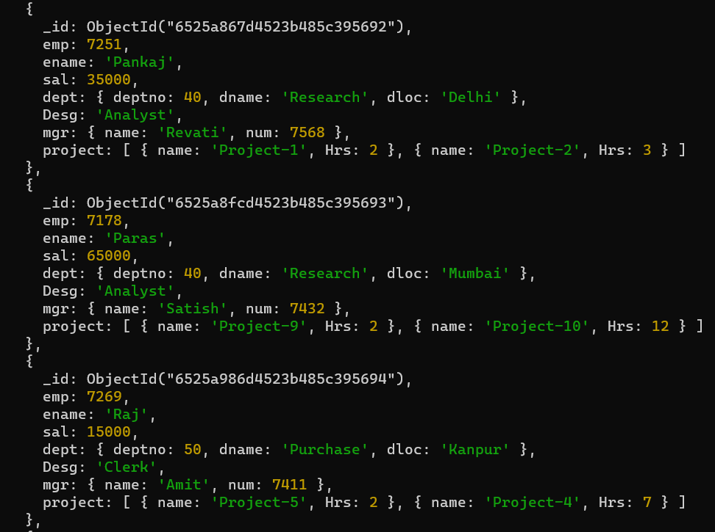

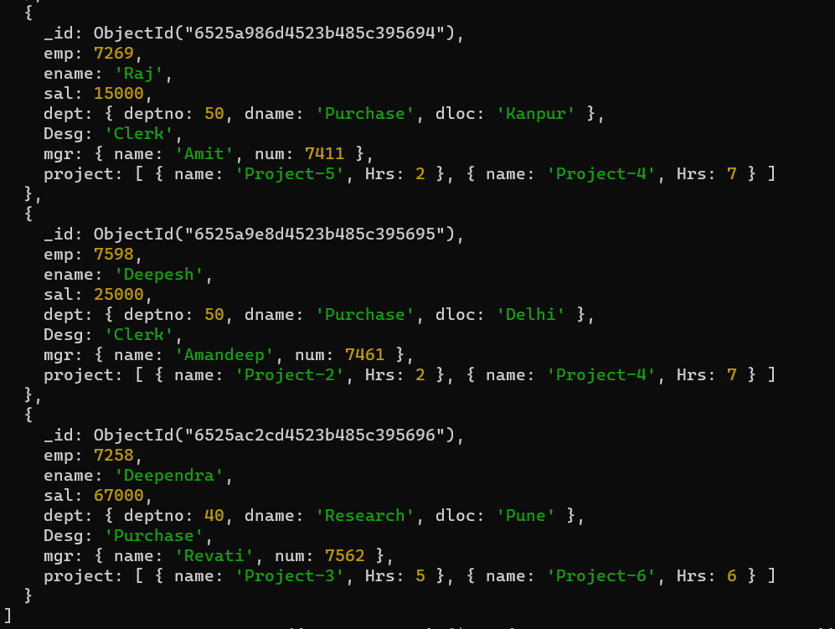

1. All Employee’s with the desg as ‘CLERK’ are now called as (AO) Administrative Officers. Update the Employee collection for this.

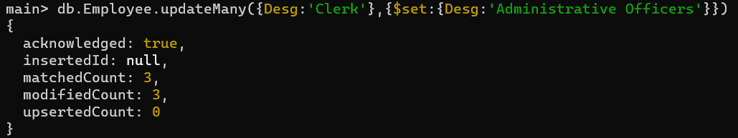

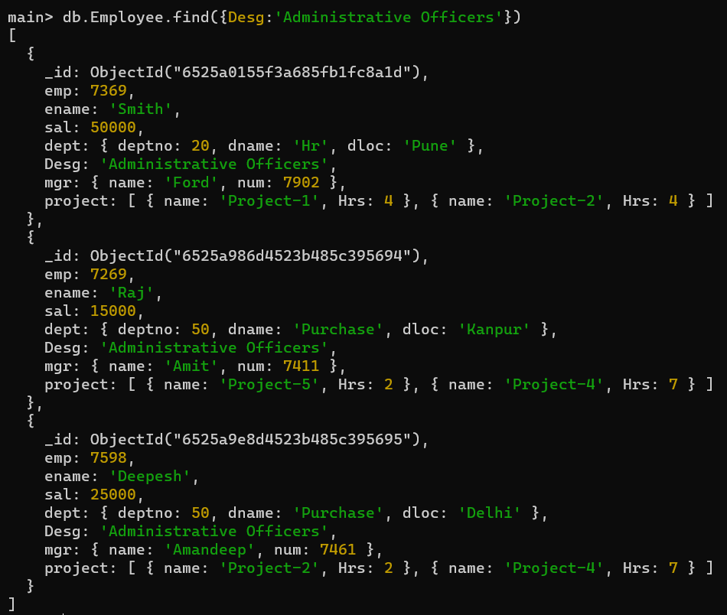

1. Change the number of hours for project-1 to 5 for all employees with designation analyst.

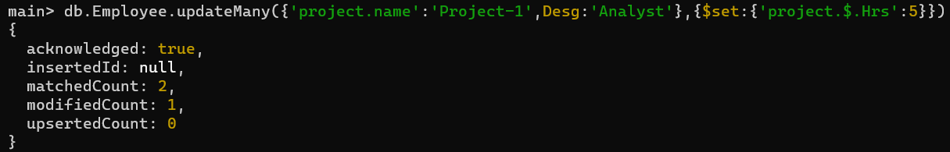

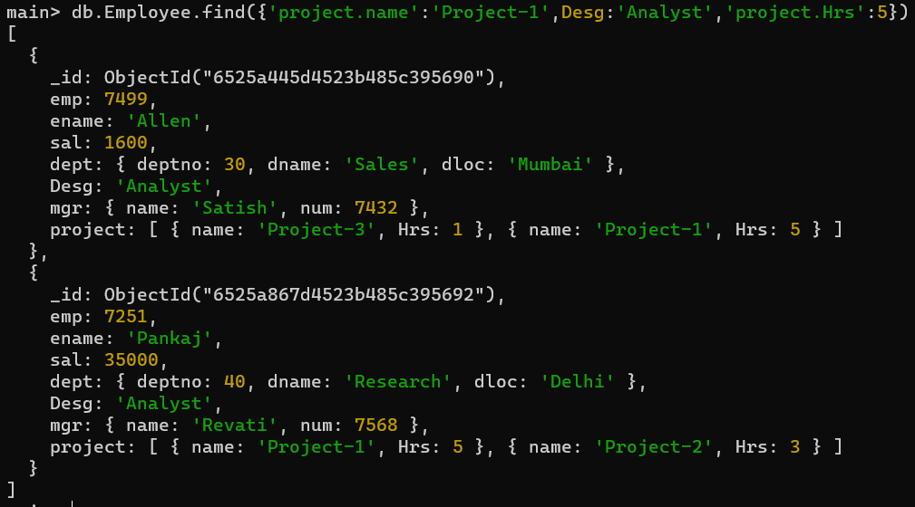

1. Add 2 projects project-3 and project-4 for employee whose name starts with ”Deep” with 2 hrs

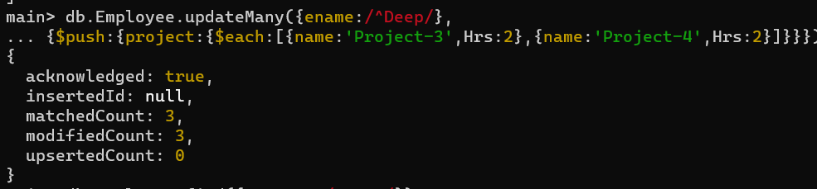

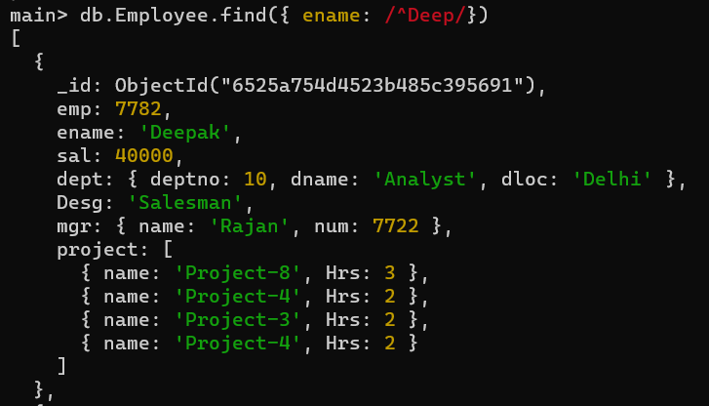

1. Add bonus rs 2000 for all employees with salary > 50000

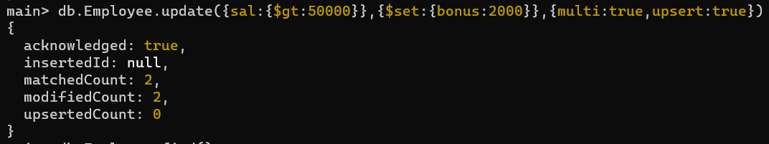

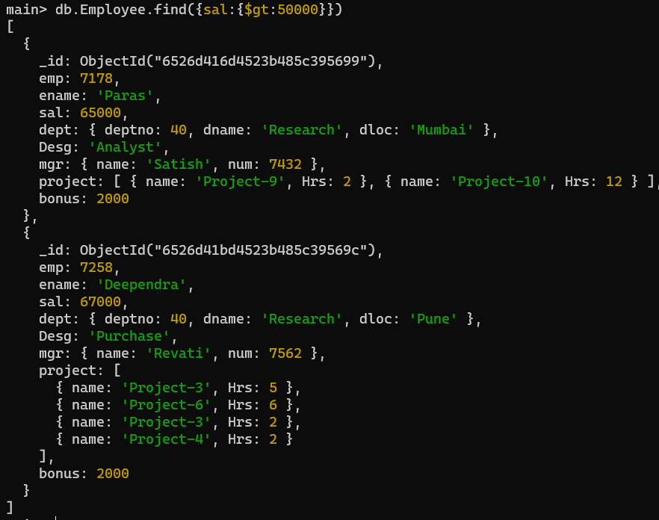

1. Add bonus rs 1500 if salary <50000 and > 30000

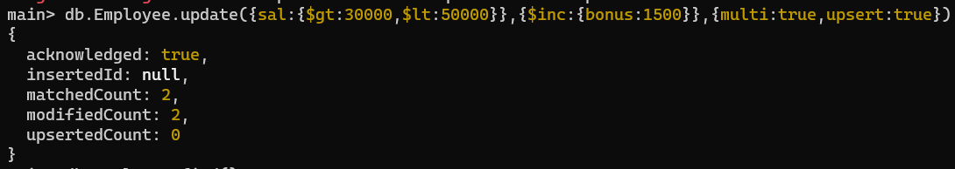

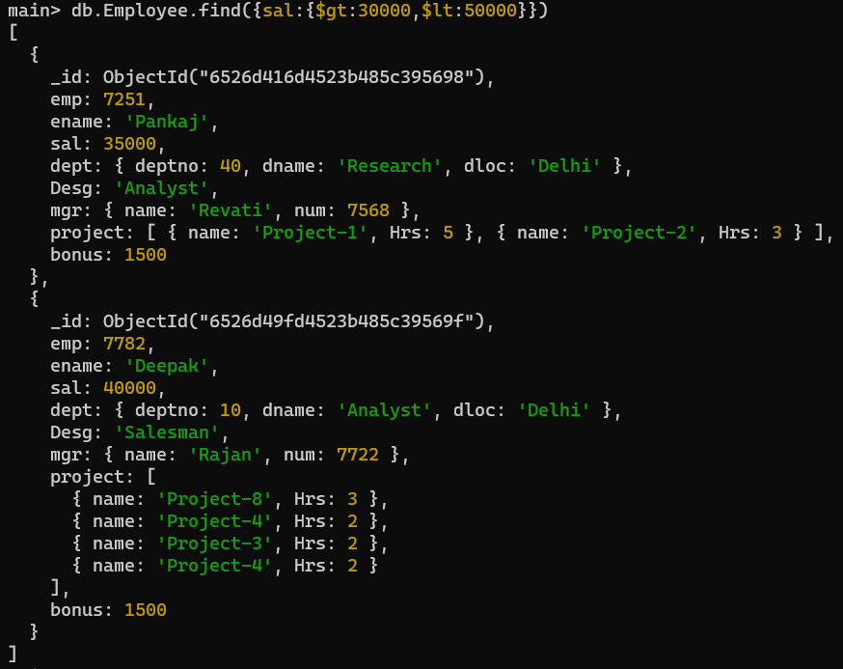

1. increment bounus by 1000 for all employees if salary <=30000

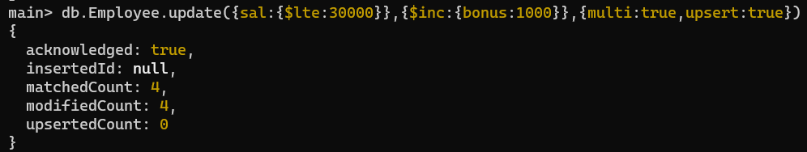

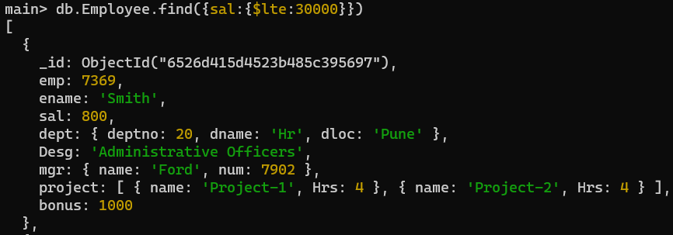

1. Change manager name to Tushar for all employees whose manager is currently “satish” And manager number to 3333

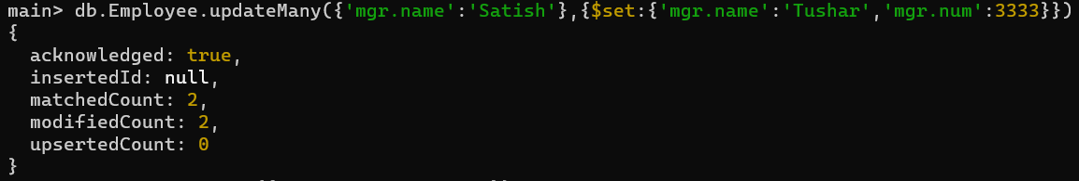

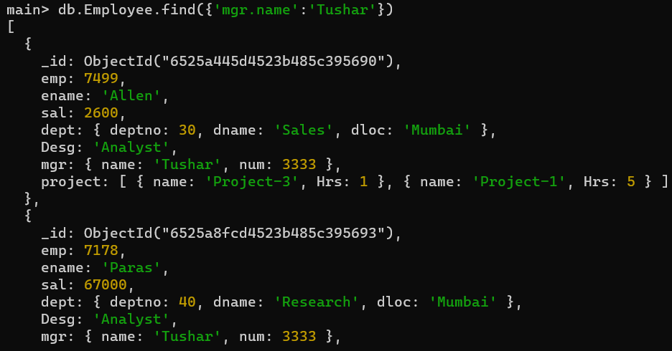

1. Increase salary of all employees from “purchase department” by 15000

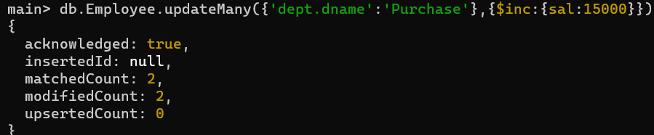

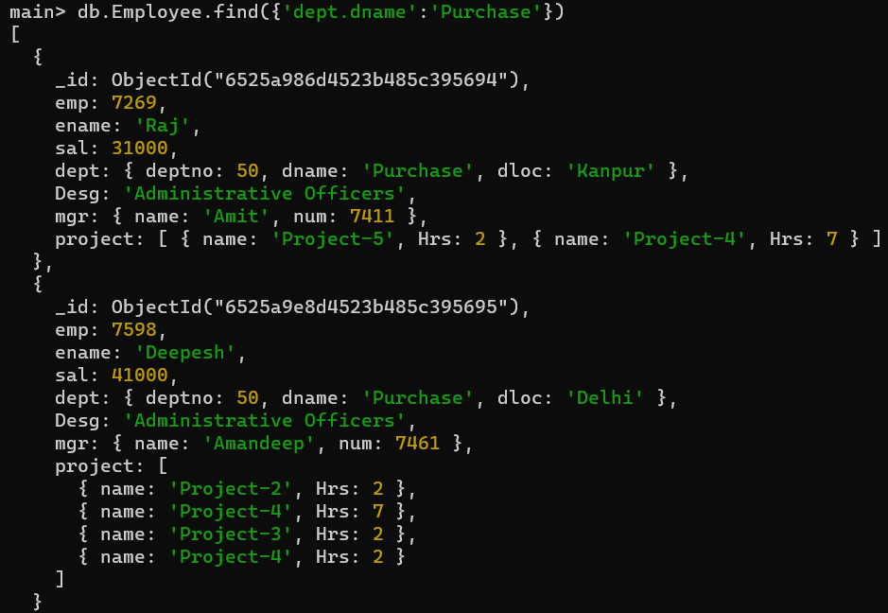

1. Decrease number of hrs by 2 for all employees who are working on project-2

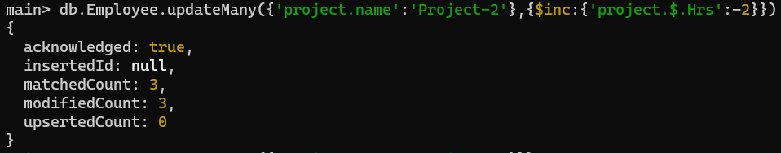

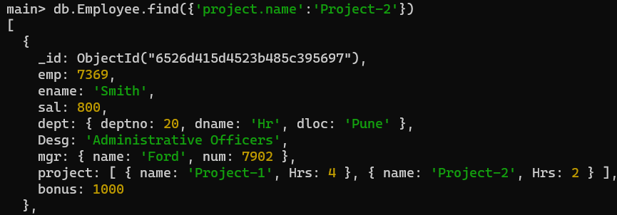

1. Delete project-4 from all employee document if they are working on the project for 7 hrs.

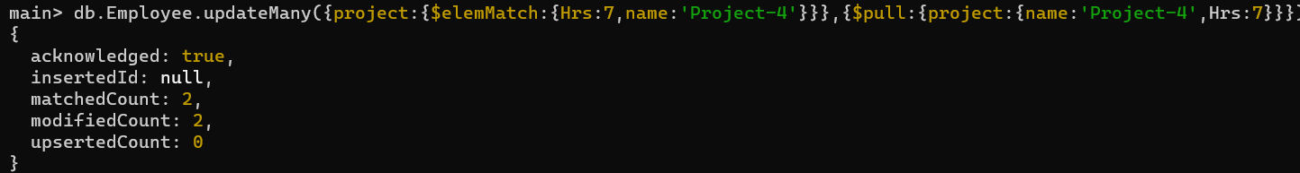



1. Change the salary of employees to 10000 only if their salary is < 10000

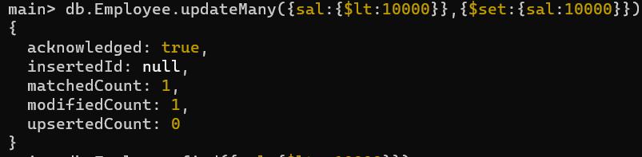

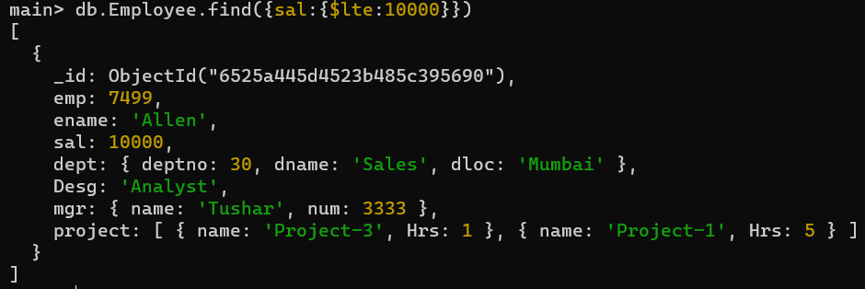

1. Increase bonus of all employees by 500 if the bonus is <2000 or their salary is <

20000 or if employee belong to sales department

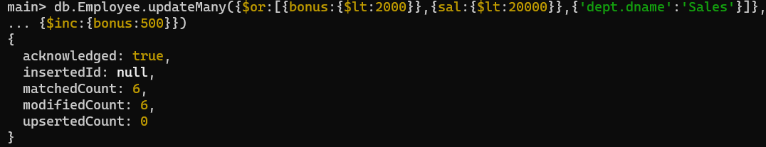

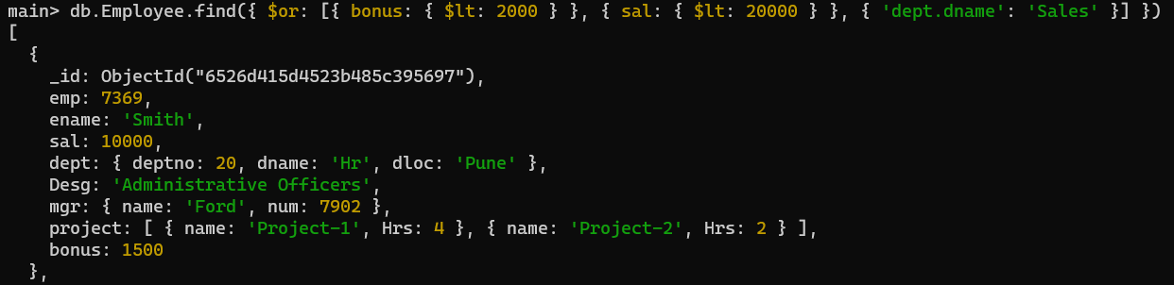

1. Add 2 new project at position 2 for all employees with designation analyst or salary is equal to either 30000 or 33000 or 35000

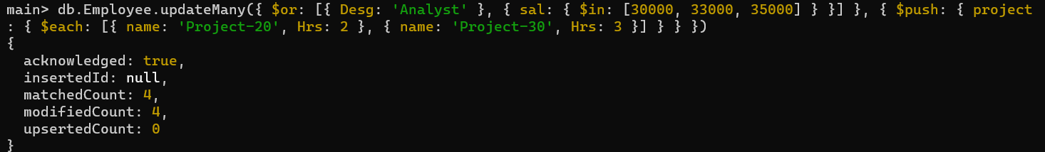

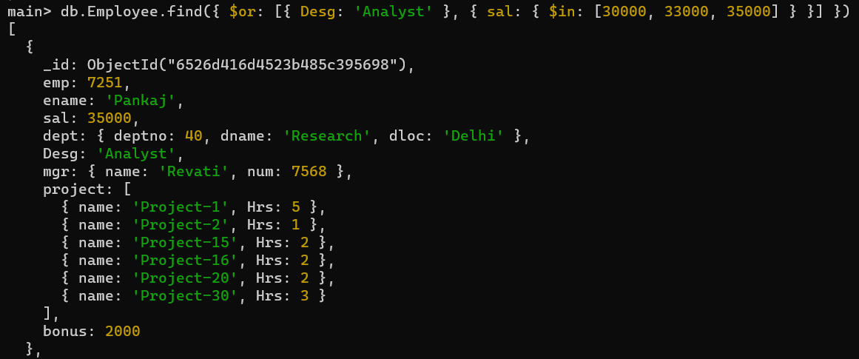

1. Delete last project of all employees with department name is “HR” and if the location is Pune

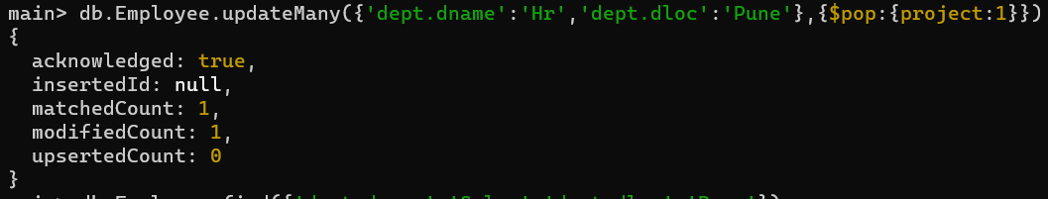

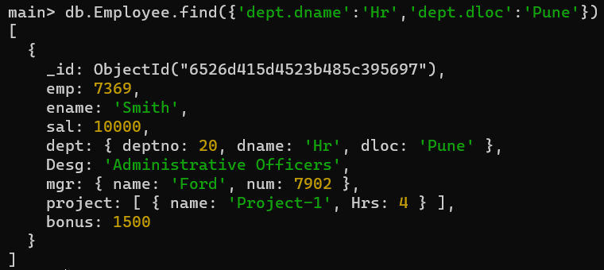

1. Change designation of all employees to senior programmer if they are working on name:”Project-1” for 4 hrs

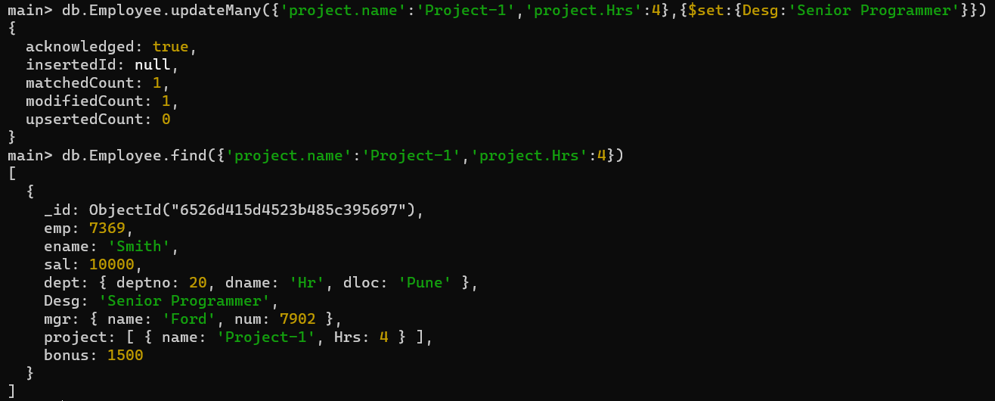

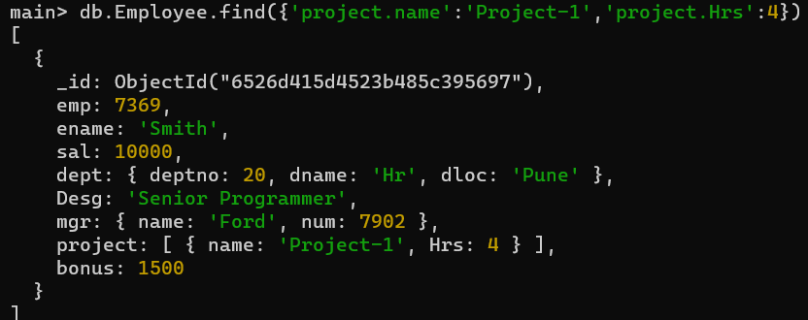

1. Add list of hobbies in all employees document whose manager is Rajan or Revati

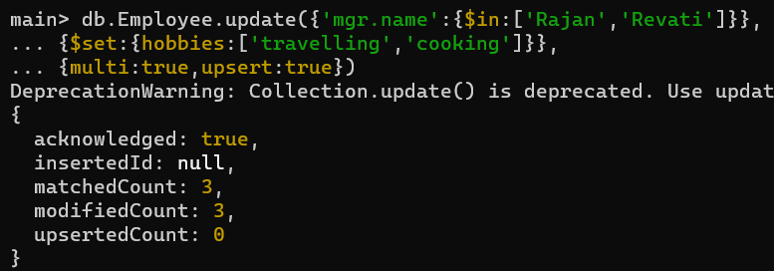

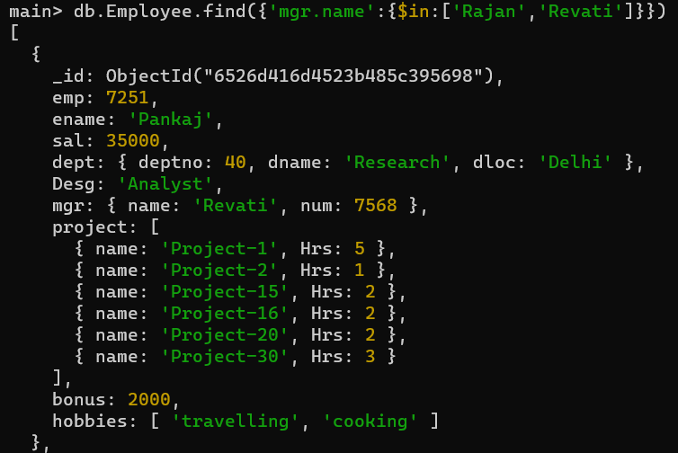

1. Add list of skillset in all employee documents who are working on project-20 for 2 hrs or on project-30 for 3 hrs

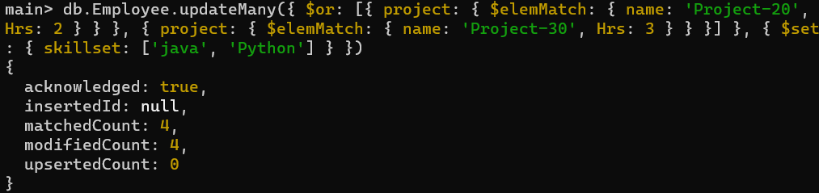

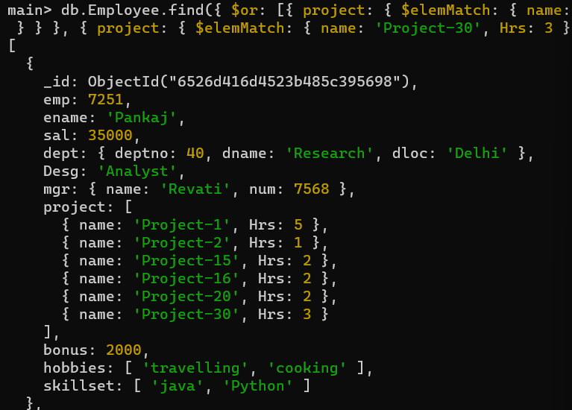

1. Add a new hobby as blogging at 3 position in hobbies array for all employess whose name starts with R or p and ends with j or s

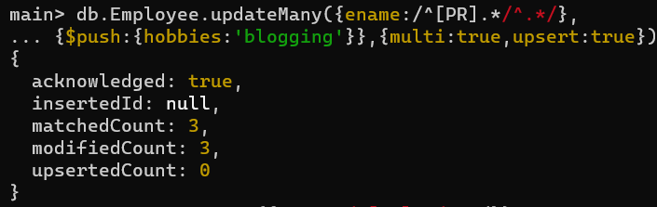

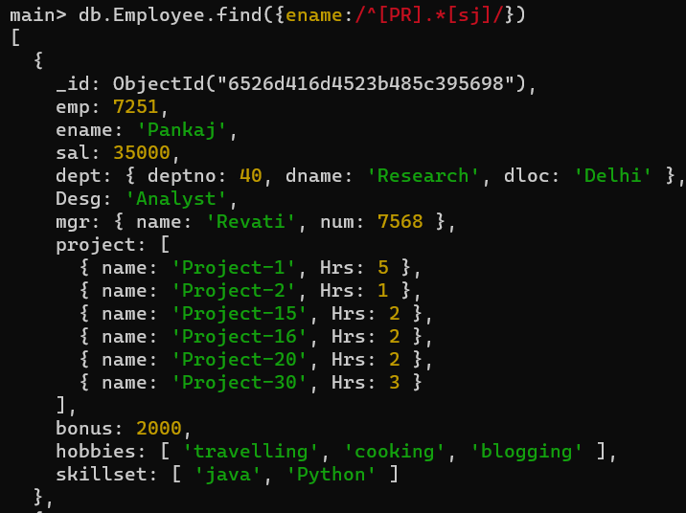

1. Increase salary by 10000 for all employees who are working on project-2 or project-3 or project-1

Decrease bonus by 1000 rs And increase salary by 1000rs for all employees whose department location is Mumbai

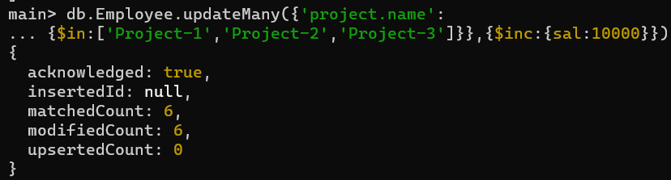

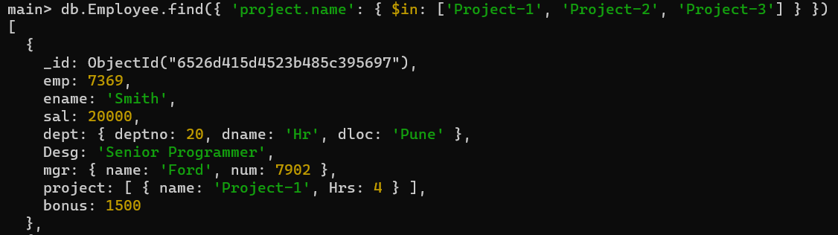

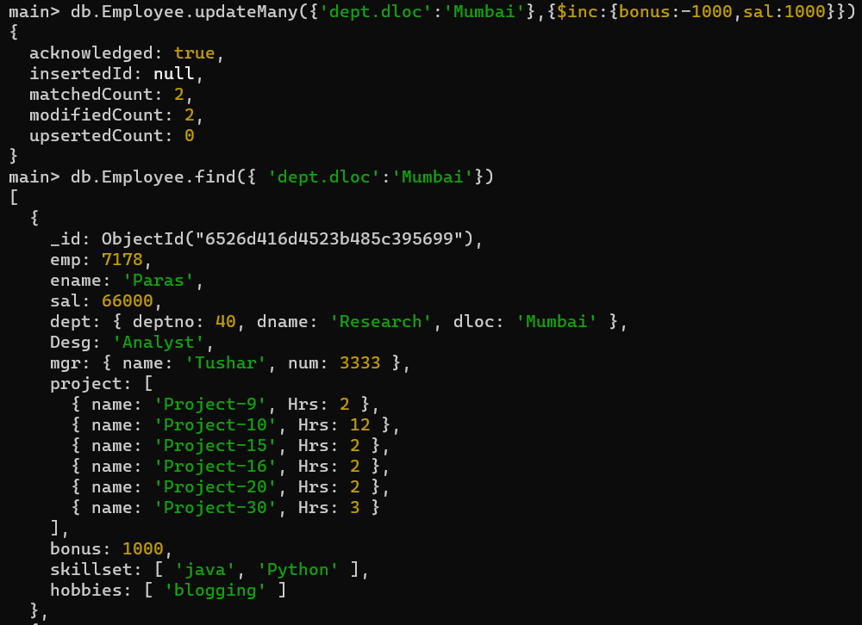

1. Remove all employees working on project-1

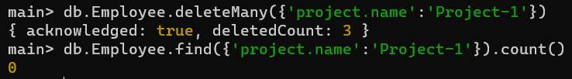

1. Replace document of employee with name “Deepak’’ to some new document
2. Change skill python to python 3.8 for all employees if python is there in the skillset
3. Add 2 skills MongoDb and Perl at the end of skillset array for all employees who are working at Pune location

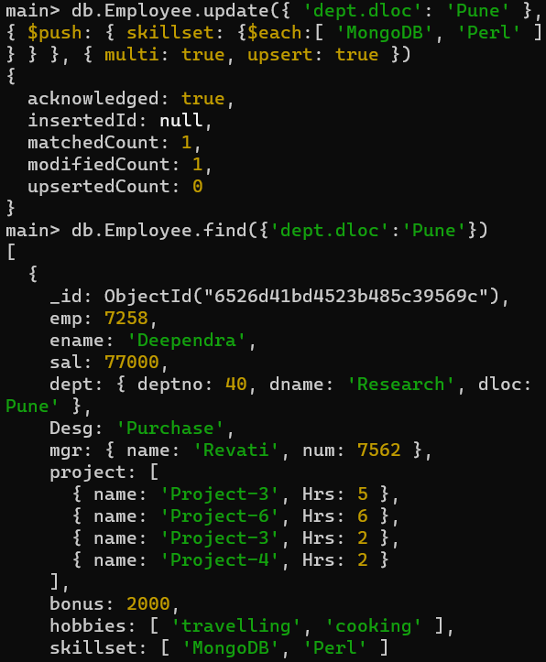

1. Delete first hobby from hobby array for all employees who are working on project-3 or project-5

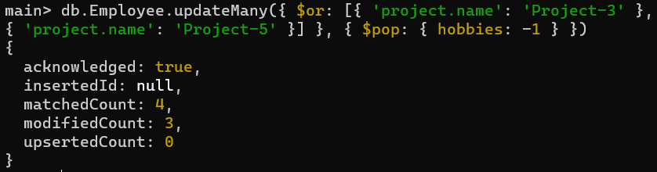

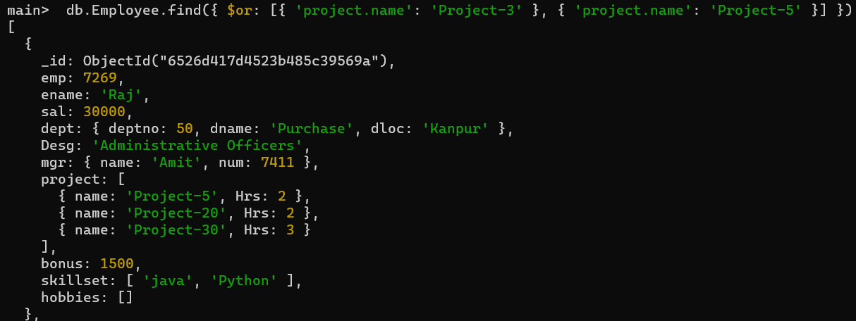

1. Delete last hobby from hobbies array for all employees who are working on project which is at 2 nd position in projects array for 2 hrs

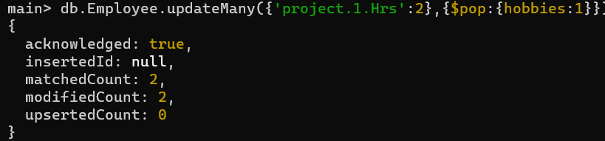

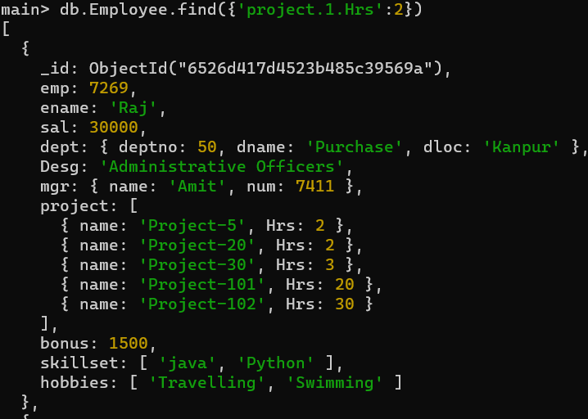

1. Add 2 new projects at the end of array for all employees whose skillset contains Perl or python

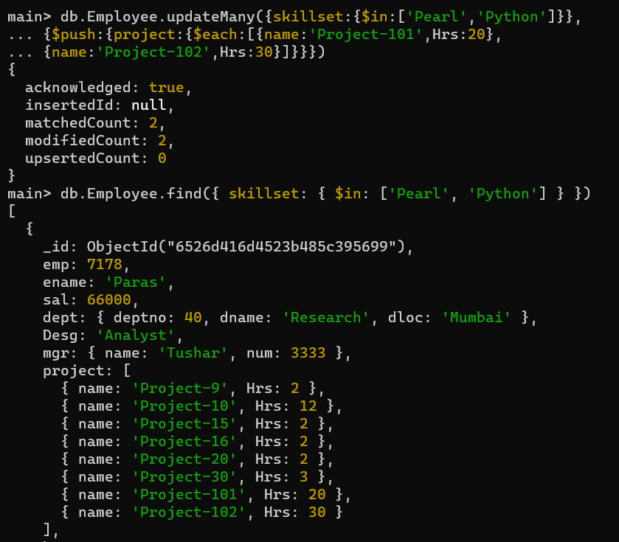

1. Change hrs to 6 for project-4 for all employees if they working on the project-1 for < 6 hrs. otherwise keep the existing value.

